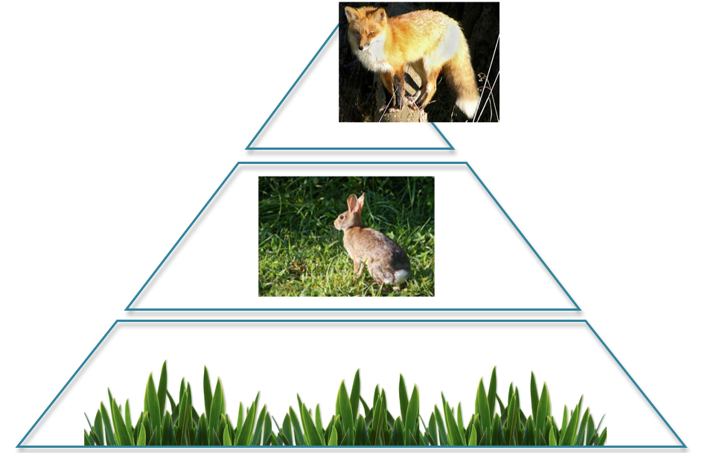
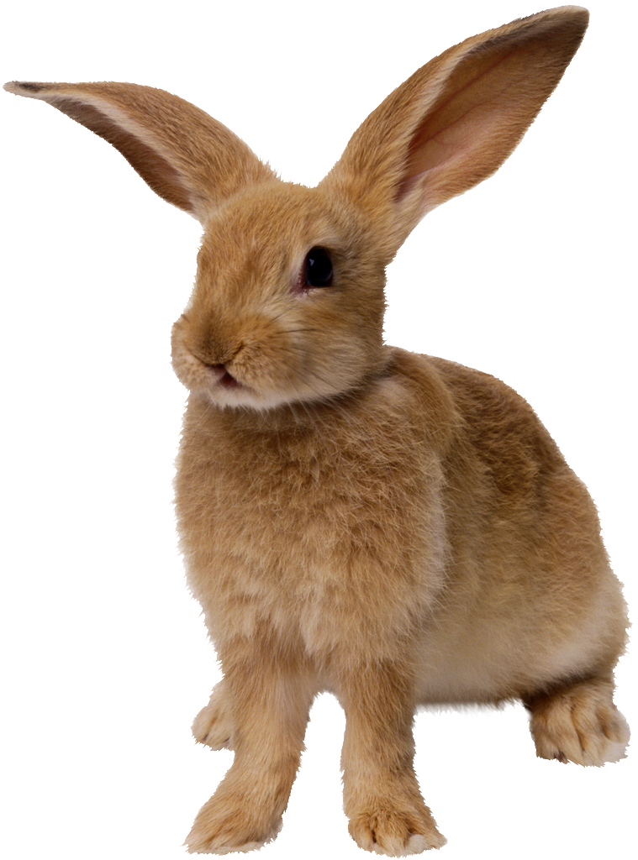
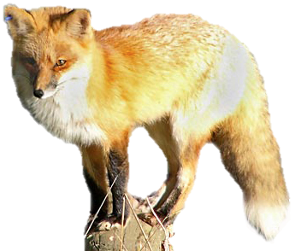
Ecosystems
Teacher’s
Guide

How ecosystems store
and cycle Carbon
and chemical energy

The Environmental Literacy Project
Carbon: Transformations in Matter and Energy
(Carbon TIME)
2011-2012

Table of Contents
Table of Contents 2
Ecosystems Timeline and Overview 3
Vocabulary: 6
Materials 6
Acknowledgments: 7
Core Lesson 1: Pre-Assessment and Carbon in Our Ecosystems 8
Activity 1: Pre-assessment 9
Activity 2: Where Is The Carbon in Ecosystems? 10
Ecosystems Preassessment 11
Worksheet with Commentary: Where Is The Carbon? 13
Core Lesson 2: Sunny Meadows Investigation 15
Activity 1: Initial Explanations and Predictions 17
Activity 3: Accounting for Results with Claims, evidence, and Reasoning 18
Worksheet: Sunny Meadows Predictions 20
Worksheet: Sunny Meadows Investigation 21
Worksheet: Sunny Meadows Results 22
Sunny Meadows Sample Data 23
Core Lesson 3: Flow of Matter and Energy In Food Chains 24
Activity 1: Carbon Game I: Meadow Ecosystem 25
Activity 2: Charting Our Paths 27
Activity 3: Tracing Our Paths Worksheet 28
Activity 4: Pools & Fluxes Worksheet 29
Activity 5: Carbon Game II: Organic vs. Inorganic 30
Activity 6: Carbon Game III - Farm Game 30
Worksheet: Carbon Game Card (Meadow) 32
Worksheet: Tracing Our Paths 34
Worksheet: Pools and Fluxes 40
Name: ___________________ Period: ____ Date: ________ 43
Game Card (Organic Inorganic) 43
Name: ___________________ Period: ____ Date: ________ 43
Farm Game Card Round 1 44
Farm Game Card Round 2 46
Core Lesson 4: Ecosystems in our Schoolyard 48
Activity 1: Your Own Ecosystem 48
Activity 2: Satellite Images of our Community: 48
Activity 3: How do Our food choices Change the carbon cycle? 49
Activity 4: Schoolyard Plots: How does Carbon cycle through our schoolyard? 49
Activity 5: How do forest fires change an ecosystem? 50
Worksheet: Draw Your Own Ecosystem 51

Ecosystems Timeline and Overview

Lesson | Activity | Lesson Description | Core Investigations | Other Investigations & Modifications | Tools for Reasoning | Formative Assessment | Media | Required Materials
CORE 1 | 1  (20 min) | Pre-assessment | Necessary |  |  | Stand-Alone formative assessment |  | Pre-Assessment
 | 2  (20 min) | Where is Carbon in Ecosystems?: Students share their initial ideas about where carbon is found in ecosystem and which organisms tend to hold the most biomass. This is also a chance to review/discuss concepts about biomass, chemical energy, and carbon sequestration/storage. |  |  |  |  |  | Public space to record ideas  Worksheet Where is the Carbon?
CORE 2 | 1  (20 min) | Initial Predictions and Explanations (for Sunny Meadows): Students make predictions about the #plants and #rabbits needed to sustain fox populations. Students also predict how they can achieve the most biomass in the system. | Necessary |  |  |  | SunnyMeadowsPredictions.ppt | Computer to project materials  Worksheet Sunny Meadows Predictions
 | 2  (30 min) | Sunny Meadows Investigation: Students use an online simulation to acquire data and make observations about what is sustainable for the 1) largest fox population, and 2) what conditions are needed for the most biomass in the system. Students should find that in order to sustain large fox population they need a large plant population and in order to sustain the most overall biomass, there are very few rabbits. They should also note that in general the grass has the largest population, followed by rabbits, and fox have the smallest population. | Necessary |  |  |  | Sunny Meadows link: http://puzzling.caret.cam.ac.uk/game.php?game=foodchain | Computers for students  Worksheet Sunny Meadows Investigation
 | 3  (30 min) | Accounting for results with Claims, Evidence, Reasoning: Students re-examine their multi-organism process diagrams to explain that producers are the ultimate source of biomass for the whole system, so fox population depends a lot on the grass population. Students begin to explain why fox populations tend to always stay smaller than rabbit or grass. | Necessary |  |  |  |  | Worksheet Sunny Meadows Results
CORE 3 | 1  (30 min) | The Carbon Game I: Meadow Ecosystem: Students take on the roles of carbon atoms moving from the atmosphere to different organisms in a meadow ecosystem. This activity helps students see that because organic matter is partitioned between growth and functioning, only some is of the organic matter is made available to the next trophic level. Students then revisit the Sunny Meadows data***. | Necessary |  |  |  | GameIntroduction.pptx | GameWorksheet_Meadow.docx,  Location card .jpgs  1 die for each student
 | 2  (30 min) | Charting our Paths: In this activity students chart the data collected from the Carbon game in an excel graph. They compare graphs of the distribution of carbon atoms and the rates of carbon-transforming processes. | Necessary |  |  |  | CarbonGame.pptx  ChartingOurPaths.xlsx
 | 3  (30 min) | Tracing Our Paths Worksheet: In this activity students use their individual data from the carbon game to trace their paths as carbon atoms through a mountain ecosystem diagram and also through a conceptual food web process tool. | Necessary (part IV is optional) |  |  |  |  | Worksheet Tracing Our Paths
 | 4  (30 min) | Pools & Fluxes: Students read a short passage about carbon pools & fluxes, and then discuss with the help of follow up questions. |  |  |  |  |  | PoolsFluxes.docx
 | 5  (45 min) | The Carbon Game II: Organic/Inorganic: A second version of the game with only two pools: organic and inorganic. Students go through 3 rounds of this game to examine the role of photosynthesis, cellular respiration, and energy in the ecosystem. |  |  |  |  | CarbonGame_OrganicInorganic.pptx | GameWorksheet_OrganicInorganic.docx,  1 die for each student, Location card jpgs
 | 6  (30 min) | The Carbon Game III: Farm Ecosystems: In this final version of the game, students examine what happens when we add people to the ecosystem. |  |  |  |  | FarmGame.pptx  ChartingOurPaths.xlsx | FarmGameCard.docx  1 die for each student  Location Card jpgs
CORE 4 | 1  (20 min) | Draw your Own Ecosystem |  |  |  |  |  | DrawYourOwnEcosystem.docx
 | 2 | Satellite Images of your Own Community | Teachers: we have purposefully left this lesson undeveloped because we are interested in hearing from you after you go through the first three lessons what application lesson you think would be most relevant and feasible in a classroom.
 | 3 | How do our Food Choices Change the Carbon Cycle?
 | 4 | Schoolyard Plots: How do carbon and energy cycle through our schoolyard?
 | 5 | How do Forest Fires Change an Ecosystem?

Targeted Grades: 6-12

Key Concepts: Biomass Pyramid, Large-Scale Carbon Cycling in Ecosystems, Carbon Pools & Fluxes, Carbon Transforming Processes, Large-Scale Energy in Ecosystems

Vocabulary:
- Biomass
- Biomass Pyramid
- Biosynthesis
- Carbon Cycle
- Carbon Flux
- Carbon Pool
- Cellular Respiration
- Chemical Energy
- Combustion
- Consumer
- Decomposer
- Digestion
- Ecosystem
- Energy Pyramid
- Inorganic Matter
- Meat-based Diet
- Organic Carbon
- Inorganic Carbon
- Organic Matter
- Photosynthesis
- Plant-based Diet
- Producer
- Sequestration

Materials
General Resources
- Computer to project
- Computer access for students (to work in groups of 2 or 3)
- TeachersGuide_Ecosystems.docx
- 1 die for each student
- SunnyMeadowsPredictions.ppt
- Pre/Post Assessment
- GameIntroduction.pptx
- CarbonGame.pptx
- Carbon Game Location Cards
- Carbon Game (Meadow)
  - AtmosphereStation.jpg
  - CarnivoreStation.jpg
  - DecomposerStation.jpg
  - HerbivoreStation.jpg
  - ProducerStation.jpg
- Carbon Game (Organic/Inorganic)
  - Round1Organic.jpg
  - Round1Inorganic.jpg
  - Round2Organic.jpg
  - Round2Inorganic.jpg
  - Round3Organic.jpg
  - Round3Inrganic.jpg
- Carbon Game (Farm)
  - Round1Atmosphere.jpg
  - Round1Cow.jpg
  - Round1Corn.jpg
  - Round1Decomposers.jpg
  - Round1Human.jpg
  - Round2Atmosphere.jpg
  - Round1Corn.jpg
  - Round1Decomposers.jpg
  - Round1Human.jpg
- LocationCards_OrganicInorganic.ppt
- ChartingOurPaths_Meadow.xlsx
- CarbonGame_Organic/Inorganic.pptx
- FarmGame.pptx
- ChartingOurPaths_Farm.xlsx

Consumable Student Worksheets
- EcosystemsPresassessment.docx
- WhereIsTheCarbon.docx
- SunnyMeadowsPredictions.docx
- SunnyMeadowsInvestigation.docx
- SunnyMeadowsResults.docx
- Game cards
  - GameWorksheet_Meadow.docx
  - GameWorksheet_OrganicInorganic.docx
  - FarmGameCard.docx
- TracingOurPaths.docx
- PoolsFluxes.docx

Acknowledgments:
Writers: Charles W. (Andy) Anderson, Jenny Dauer, Amy Lark, Hannah Miller, Lindsey Mohan, Li Zhan

Reviewers and assistance from: Add names here

Core Lesson 1: Pre-Assessment and Carbon in Our Ecosystems

Time/Duration: 40 minutes
Activity 1: Pre-assessment ~20 minutes
Activity 2: Where Is The Carbon in Ecosystems? ~20 minutes

Guiding Question: Where is the carbon located in an ecosystem?

Model Responses
Alex | Blake | Carmen
You might find some carbon in plants, but mostly it’s given off by animals. | Carbon is stored in all living things, so it’s taken in by plants for photosynthesis and breathed out by animals. | Carbon is found in all the biomass of the ecosystem—plants, animals, and decomposers—and as carbon dioxide in the air.

The two main locations for carbon in ecosystems is as organic matter in biomass and as carbon dioxide in the air. The ecological carbon cycle is one way to describe carbon moving between these two locations. Carmen (Level 4) identifies both locations, which shows that Carmen understands biomass as a critical storage reservoir for carbon. Blake (Level 3) explains that carbon is in all living things, so Blake is on the way to this same understanding. But Blake focuses mostly on carbon entering plants through photosynthesis and exiting animals as they breathe. Blake explains macroscopic processes but will need to learn more about large-scale reservoirs and fluxes of carbon between biomass and carbon dioxide. Like Blake, Alex (Level 2) also focuses on carbon dioxide from animals. Alex will need additional help understand the biomass stored in living things and the general movement of carbon between living things and the surrounding air.

Learning Objectives:
The goal of the Ecological Carbon Cycle unit is to introduce students to matter cycling and energy flow in ecosystems. Students must understand that to support a large biomass in ecosystems, there needs to be large plant populations. Plants are the key source of incoming chemical energy and organic matter, and the only organisms in the ecosystem that transform inorganic carbon into energy-rich organic carbon. Students must also understand that when carbon cycles through ecosystems, the pools of carbon in various locations change, and the size of these pools change because of varying rates of carbon-transforming processes (photosynthesis, biosynthesis, digestion, and cellular respiration). Finally, students should be able to apply their knowledge of large-scale carbon cycling to ecosystems they are familiar with.

Lesson 1 is the “Establishing the Problem” part of the learning cycle for students’ accounts of transformations of carbon in ecosystems—one set of key carbon-transforming processes. In this lesson students should:
- Express their ideas about food chains and ecosystem dynamics.
- Identify knowledge that they can use during the unit.
- Identify questions that they hope to answer during the unit.

Rationale & Background:
Learning about carbon cycling means tracing carbon molecules and energy forms within and between systems. The carbon in our ecosystems is found in organic molecules in our living biomass, as well as inorganic forms like carbon in soil, graphite, and limestone. Another inorganic form that is particularly important to ecosystems is carbon dioxide in the air. Living systems continuously exchange carbon with the atmosphere, moving carbon back-and-forth between inorganic carbon dioxide and organic biomass. Understanding key reservoirs of carbon in our ecosystems—mainly biomass and carbon dioxide—can help students develop an understanding of transformations between these two key forms.

Lesson Description:
This lesson has two parts:
- In Activity 1 students take a pretest, either online or paper and pencil, then write about and discuss their experience in taking the pretest.
- In Activity 2 students are given time to write about and discuss their ideas about where carbon is located in an ecosystem. The first part of the lesson includes individual or partner reading and writing, followed by whole group discussion about these questions.

Lesson Materials:
General
- Public space to record students’ ideas
Per Student
- Ecosystems Pre-Assessment
- Worksheet Where Is The Carbon?

Advance Prep:
- Print pre-assessment and student worksheet

Activity 1: Pre-assessment
Time: About 20 minutes
Materials:
- Ecosystems Pre-Assessment (included in the Teacher’s Guide below, and also in Ecosystems Package> Core Lesson 1>Activity 1: Ecosystems_Preassessment.doc)

Rationale and Description:
The pre-assessment is useful for two purposes:
- Your students’ responses will help you decide how much detail you want to include, particularly details about biomass and energy pyramids, and large-scale carbon cycling. If your students are mostly at Level 2, you may want to save some details for later.
- Your students’ responses will provide a starting point for discussions about the focus for this unit.

Directions
- Please administer the assessment with paper and pencil (the paper version will fit on the front and back of one page).
- Explain the purpose of the pre-assessment to your students:
  - It will help you as a teacher understand how they think about food chains and food webs, and the matter and energy cycling in ecosystems.
  - It will help our research project to develop better teaching materials and activities by helping the researchers to understand how they think and how they learn.
  - It will help them to think about what they know and what they would like to learn.
- Give the students about 20 minutes to complete the test. When students turn in the pre-assessment, pass out worksheet Where Is The Carbon?

Activity 2: Where Is The Carbon in Ecosystems?

Time: About 20 minutes

Materials:
- Worksheet: Where is the Carbon? (Located in the Teacher’s Guide below, and also in Ecosystems Package> Core Lesson 1> Activity 2: WhereIsTheCarbon.doc)

Rationale and Description:
This activity is an opportunity for your students to share their initial ideas about where carbon is located in ecosystems, and an opportunity to identify which organisms they believe store the most carbon in the ecosystems (not including decomposers at this point). This is also an opportunity to review key concepts and vocabulary that students will see throughout the unit, such as biomass and chemical energy. You will also introduce the new vocabulary words, “ecosystem,” “carbon sequestration/carbon storage,” and “carbon reservoirs.”

Directions
- Pass out the worksheet Where Is The Carbon?
- Read through the first paragraph as a whole class. This paragraph introduces students to the definition of an Ecosystem. If necessary review what students already know about ecosystems. For example, you might ask:
  - What are the non-living components of an ecosystem? (dirt/non-living parts of soil, rocks, air, water, etc).
  - What are the living components of an ecosystem? (plants, animals, decomposers).
  - What are different kinds of ecosystems? (students may name large ecosystems like deserts, forests, grasslands, tundras, etc or smaller ecosystems, like a local park, garden, small pond, etc).
- Ask students to view the images of two ecosystems—desert and forest—and respond to the two questions below the images. Give students about 5 minutes to respond. As they complete the questions, allow them a couple minutes to discuss their ideas with a partner. Then open the discussion up to the whole group. Consider recording a vote by the class on the ecosystem with the most carbon, and then record a list of places students identify as having carbon.
- Have students then consider the 4 organisms they can find in both ecosystems and which population might hold the most carbon. NOTE: you may need to stop at this point and introduce the term “population” to students. A population is a group of organisms of the same species that occupy the same area.
- Read through responses by Alex, Blake and Carmen. Have students vote on the best explanation, and then explain their choice.
Spend ample time allowing students to discuss these questions aloud as a whole group, probing what they already know about carbon storage in ecosystems

Name: _____________________ Period: ____ Date: ________

Ecosystems Preassessment
1. Your muscles are made of proteins, fats, and other materials that contain many carbon atoms. Think about where those carbon atoms came from.

Which of the following statements is true? Circle the letter of the correct answer.
a. ALL of the carbon atoms came into your body in food, OR
b. SOME of the carbon atoms were made by your muscles when your muscle cells grew and divided.
Circle the best choice to complete each of the statements about possible places where the carbon atoms in your muscles might have come from.
How many of the carbon atoms were once in the AIR? | All | Most | Some | None
How many of the carbon atoms were once in the PLANTS? | All | Most | Some | None
How many of the carbon atoms were once in the ANIMALS? | All | Most | Some | None
How many of the carbon atoms were once in the DECOMPOSERS? | All | Most | Some | None
Explain your choices. How might the carbon atoms have gotten to your muscles?

2. Here is a simple food chain with one plant, one animal, and some decomposers:
Grass | is eaten by | Rabbit | Dies and is  decomposed  by | Decomposing  bacteria

Describe what happens to matter and energy in this food chain by filling in the following table:
 | Matter | Energy
Similar matter and energy | How are the materials in the grass, the rabbit, and the bacteria all alike? | How are the types of energy in the grass, the rabbit, and the bacteria all alike?
Different matter and energy | How are the materials in the grass, the rabbit, and the bacteria different form one another? | How are the types of energy in the grass, the rabbit, and the bacteria different from one another?
Connections | How are the materials in the grass, the rabbit, and the bacteria connected? | How is the energy in the grass, the rabbit, and the bacteria connected?

3. A scientist started sorting materials into two groups. Here are the first materials that she put into each group:
Group A: wood, meat, mushrooms | Group B: Sand, water, limestone

a. Which group would you put these materials in?
Salt Group A Group B
Sugar Group A Group B
Fat Group A Group B
Carbon dioxide Group A Group B
Soil minerals that help plants grow Group A Group B
Leaves of a living tree Group A Group B

b. Explain how you decided. How are the materials in Group A different from the materials in Group B?

c. Is there a different way of grouping the materials that makes more sense to you?
YES NO

d. Explain your answer. How would you group the materials differently, or why do you like these groups?

4. A remote island in Lake Superior is uninhabited by humans. The primary mammal populations are white-tailed deer and wolves. The island is left undisturbed for many years. Select the best answer(s) below for what will happen to the average populations of the animals over time.
_____a. On average, there will be more deer than wolves.
_____b. On average, there will more wolves than deer
_____c. On average, the populations of each would be about equal.
_____d. The populations will fluctuate, with sometimes more deer, sometimes more wolves
_____e. None of the above.
Please explain your answer to what happens to the populations of deer and wolves.

5. Answer these true-false questions:
True False Carbon is a kind of atom.
True False Carbon is a kind of molecule.
True False There is carbon in the air.
True False There is carbon in pure water.
True False There is carbon in the soil.

Name: _____________________ Period: ____ Date: ________

Worksheet with Commentary: Where Is The Carbon?

Ecosystems are communities of living organisms and their non-living environment. Living organisms can be as small as microscopic bacteria in the soil, or as large as the largest tree in the forest. The organisms you find in an ecosystem depend a lot on where the ecosystem is located on Earth. This changes the average temperatures, rainfall, and hours of sunlight the ecosystem receives, among many other factors. That is why we have many, many types of ecosystems on Earth, from deserts to grasslands to tropical forests.

Look at the two ecosystems below. On the right is a desert ecosystem found in the southwest of the United States, in Arizona. On the left is a forest ecosystem found in the Midwest of the United States, in Michigan.
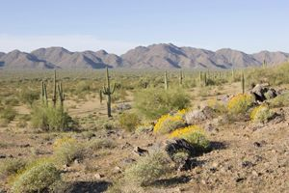
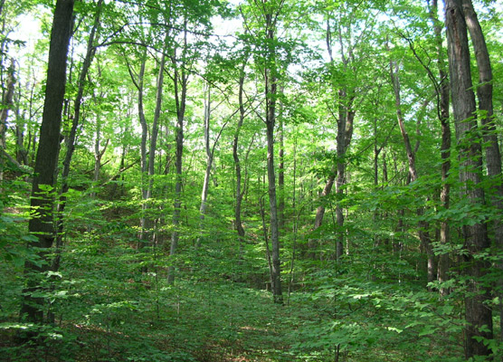

1. Which ecosystem do you think stores the most carbon? Explain why this ecosystem has more carbon than the other ecosystem.
Students will likely identify the forest as storing more carbon because it simply contains more living things. For this reason, students from Levels 2 to 4 might answer the same way on this question. In their explanation, students at Levels 3 and 4 will likely give an explanation that connects to a chemical basis of living things (identifying chemical processes or chemical substances), while level 2 students will simply associate carbon with MORE living things.

2. Name all the places where you would find carbon in the ecosystems.
Students at Level 4 will identify critical biomass reservoirs, including plants, animals, AND decomposers in the soil (as well as carbon dioxide in the air). They may also identify other forms of inorganic carbon (such as limestone, graphite, etc.).

Level 2 and 3 students will likely identify plants and animals as the critical carbon reservoirs in the ecosystem. In addition, Level 3 students can identify chemical processes changing carbon in the ecosystem and may identify common carbon substances.

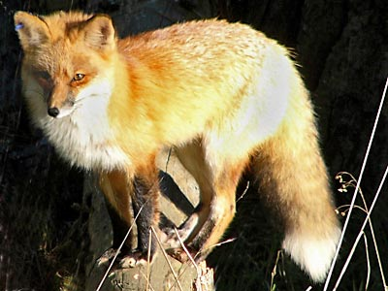
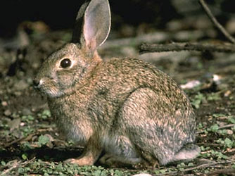
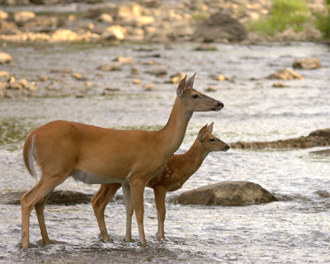
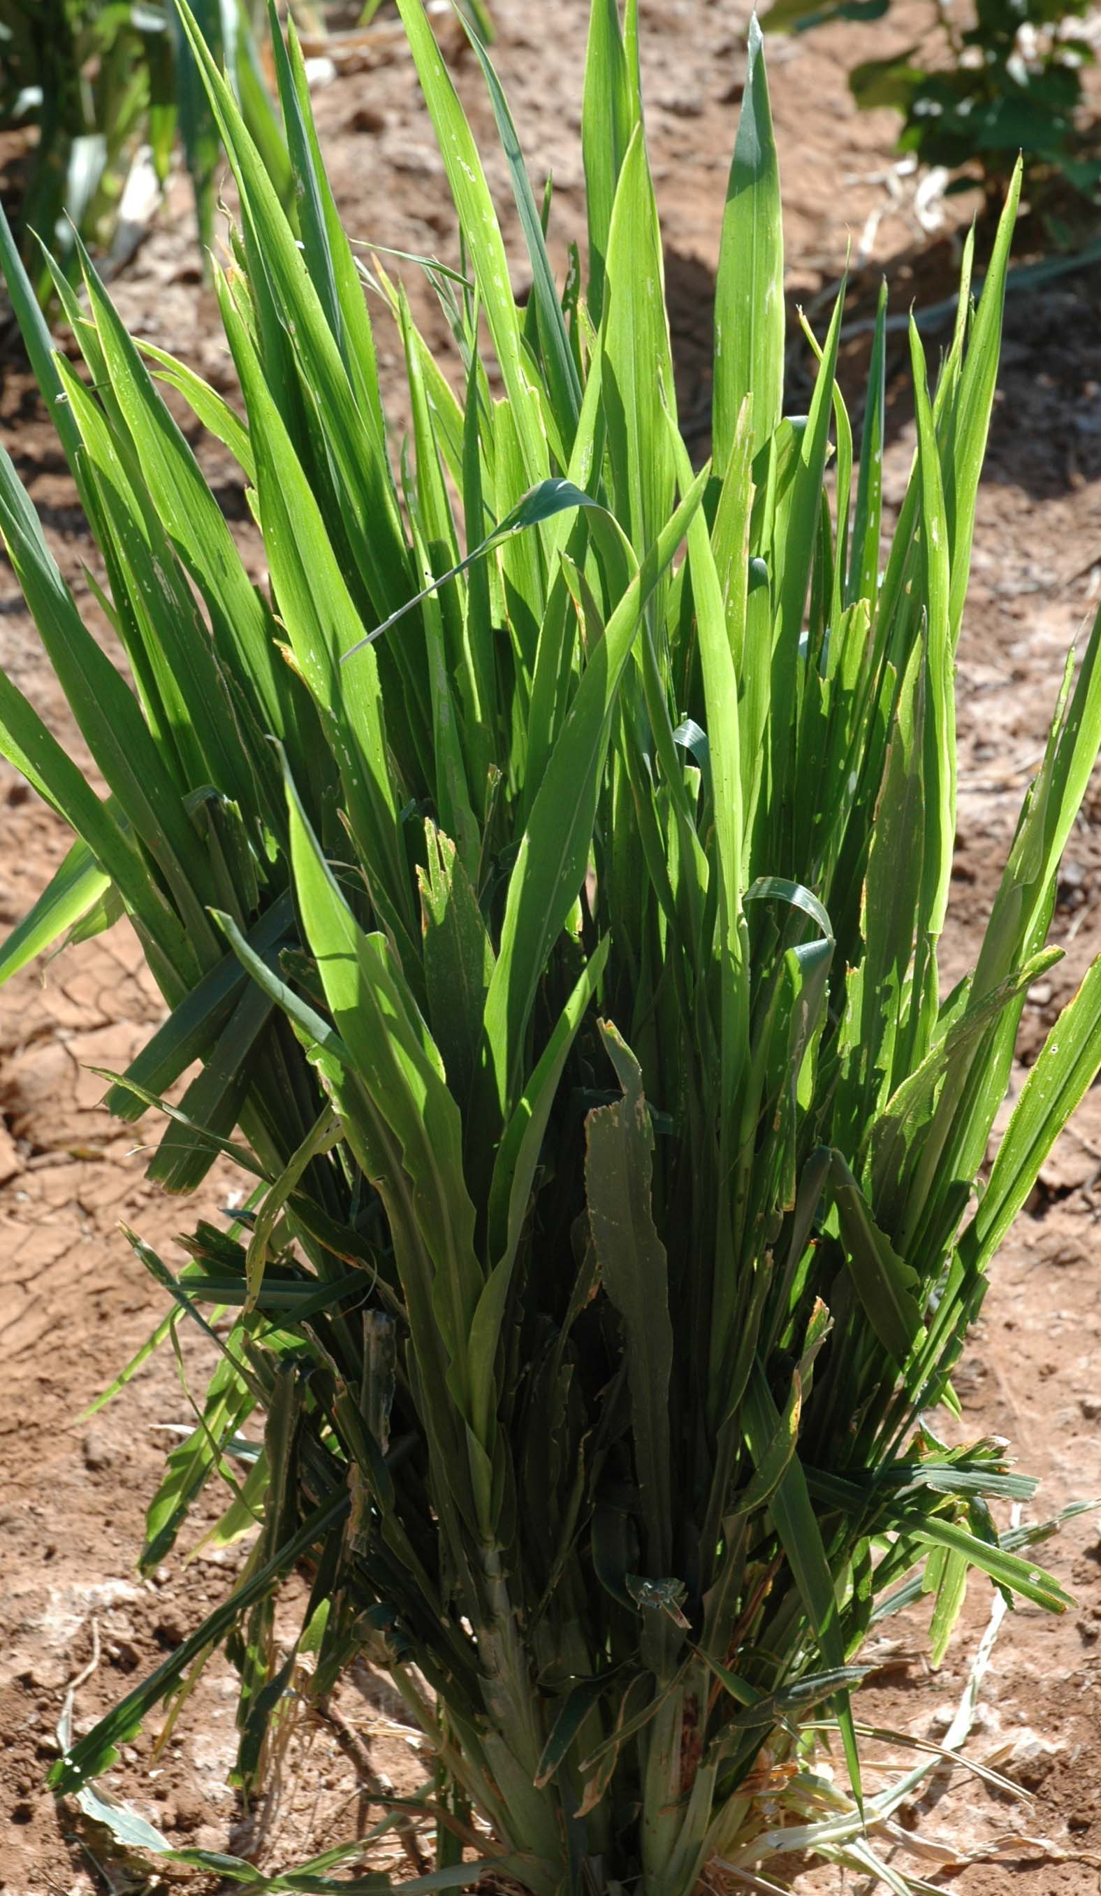
In desert ecosystems and forest ecosystems you can find different species of fox, deer, rabbits and plants.

Which one of these populations of organisms would hold the most carbon in the ecosystem?
- All the plant population in the ecosystem
- All the rabbit population in the ecosystem
- All the deer population in the ecosystem
- All the fox population in the ecosystem

3. Explain your choice. Why does that population hold more carbon than the others?
Level 4 students will recognize that producers are the largest reservoir of carbon in an ecosystem. Students may justify this choice with an explanation about biomass/energy pyramids or an explanation that not all the carbon/chemical energy passes on to higher trophic levels.
Level 2 and 3 students may focus on fox or deer because they are “larger” in size or higher in the trophic levels (as is the case with the fox). Level 3 students will justify this explanation using descriptions of predator-prey relationships, food chain relationships, and/or identifying that deer or fox have larger mass than plants and rabbits. Level 2 students will likely focus on visible size and numbers outside the context of relationships between organisms in the ecosystem.

Alex, Blake and Carmen were asked the same question. Look at how they answered the question and circle which answer you think is best.


Carmen: The plants have the largest population so they would hold more carbon than the others.
Alex: Deer are the largest size so they would have the most carbon in the ecosystem.
Blake: Fox are the top predator so they would have more carbon than the others.

4. Why is the one you circled better than the other two explanations?
Alex, Blake, and Carmen generally represent Level 2, Level 3, and Level 4 reasoning. So students choices of the explanation they liked best can give you a quick indication of what level they are at—but not as accurate an indication as the pretest.

Core Lesson 2: Sunny Meadows Investigation

Time/Duration: 80 minutes
Activity 1: Initial Predictions and Explanations ~20 minutes
Activity 2: Sunny Meadows Investigation ~30 minutes
Activity 3: Accounting for Results with Claims, Evidence,
and Reasoning ~30 minutes

Guiding Question: What happens to a fox population when there are changes in the amount of rabbits and grass in their ecosystems?

Model Response:
Alex | Blake | Carmen
If there are not enough rabbits the foxes would probably die because they do not eat grass. Only the strongest foxes would survive. | The fox population would decrease if rabbit population decreases because they are directly connected in their food chain. And rabbits need grass, so foxes depend on both grass and rabbits. | To keep a stable fox population you need large and stable rabbit and grass populations, with grass having a larger population (and biomass) than rabbits.

All animals in an ecosystem depend on the primary productivity in the ecosystem. Plants are the critical source of incoming organic matter and chemical energy. But some students may believe that animals are only dependent on their immediate food source. Carmen (Level 4) recognizes that plants are critical to the stability of the fox population even given that they are not directly connected in a food chain. Having a large plant population provides the organic matter for the rabbits (immediately), but the plant is also a critical source biomass in higher trophic levels, and for long-term biomass storage. Blake (Level 3) recognizes that fox are ultimately dependent on plants too, but focuses mostly on the fox’s dependence on the rabbit population. For Alex (Level 2), the fox’s dependence on rabbits is the only relationship in the system, because Alex does not see a connection between fox and grass/plants.

Learning Objectives:
This lesson introduces students to an investigation of ecosystems through an online simulation of a simple food chain. This investigation involves students engaging in two inquiry practices: making observations and arguments from evidence:
- Making Observations involves the following three observations:
  - The fox biomass can be large only if the plant biomass stays large
  - The biomass peaks when there are no rabbits
  - Rabbit biomass is always smaller than plant biomass, and fox biomass is still smaller.
- Constructing Arguments from Evidence involve connecting:
  - Claims: Explanation of what is needed to maintain a large and stable fox population and large amounts of biomass
  - Evidence: Population counts of rabbits and plants necessary to sustain a large and stable fox population; Population counts when the biomass is largest across all three populations.
  - Reasoning: Showing that claims (a) are supported by the evidence and (b) are consistent with principles that constrain the practices.

The goals of this lesson include:
Objectives for students at Level 2 | Objectives for students at Level 3
- Observe that fox populations depend on grass populations as well as rabbit populations  - Explain that foxes have smaller biomass than rabbits, and that rabbits have smaller biomass than grass  - Construct arguments about biomass in ecosystems based on evidence in their worksheets and investigations | - Observe that foxes depend on larger rabbit populations, which in turn depend on larger grass populations.  - Explain that organisms in higher trophic levels contain less biomass than the populations they depend on for food, and if these balances in biomass are disturbed, the ecosystem becomes unstable  - Construct arguments about biomass in ecosystems based on evidence in their worksheets and investigations

Rationale & Description:
In this lesson students use an online simulation allows students to run multiple scenarios over and over again, essentially hypothesizing, testing, and hypothesizing again until students begin to see patterns in the way the ecosystem changes as populations change. The simulation, Sunny Meadows, allows students to adjust populations of plants, rabbits, and fox to observe changes in populations over a 50-year period. In this investigations students will be asking two key questions and making the three critical observations already mentioned on the previous page. The investigation questions are:
- What is the maximum sustainable fox population? What initial conditions lead to that population? Here students can see that there must be far fewer foxes than rabbits, and less rabbits than grass. So the fundamental limit on consumer populations is net primary productivity.
- How can the system have the greatest total biomass? Here students can see that the best way to have a large total biomass is to have no consumers at all, but if there are consumers, the foxes contribute to sustaining larger biomasses by limiting the rabbit population.

Lesson Description:
Activity 1: Students make their initial predictions and explanation about the number of plants and rabbits needed to sustain a large and stable fox population (around 100 foxes). Students also predict and explain the biomass they believe could be stored in each population to maximize overall biomass.
Activity 2: Students run the Sunny Meadows online simulation try to maintain a large and stable fox population and trying to maximize overall biomass. They only record their most successful attempts for both.
Activity 3: Student revise their explanation of what happens in the ecosystem based on their observations in Sunny Meadows. They then use a claims-evidence-reasoning framework to assess (a) how well their explanations are supported by evidence and (b) how well their explanations follow the accounts practices and principles.

Materials:
General
- Computer access for students
- Computer to project
- SunnyMeadowsPredictions.ppt
Per Partners/Student
- Computer
- Worksheets:
  - SunnyMeadowsPredictions.doc
  - SunnyMeadowsInvestigations.doc

Advance Prep:
- Have computer and SunnyMeadowsPredictions.ppt ready to project
- Have computer access for students to complete the investigation
- Print worksheets for each student
  - SunnyMeadowsPredictions.doc
  - SunnyMeadowsInvestigation.doc
  - SunnyMeadowsResults.doc

Activity 1: Initial Explanations and Predictions

Time: 20 minutes
Materials:
- Power Point: SunnyMeadowsPredictions.ppt (Located in the Ecosystems Package> Core Lesson 2> Activity 1: SunnyMeadowsPredictions.ppt)
- Worksheet: SunnyMeadowsPredictions.doc (Located below in the teacher’s guide, and also in Ecosystems Package> Core Lesson 2>Activity 1: SunnyMeadowsPredictions.doc)

Rationale & Description:
Students express their initial ideas about what happens to the biomass, O₂, and CO₂ when changes are made to the plant, rabbit, and fox populations.

Directions:
- Give students the Worksheet SunnyMeadowsPredictions.doc.
- Ask them to record their own predictions and explanations on the worksheet.
- When they have finished, ask them to share their predictions with the class. Record predictions in the Power Point document SunnyMeadowsPredictions.ppt. Alternatively, if your school computers do not support power point, record predictions in a public location on your classroom computer where they can be accessed again.

Activity 2: Sunny Meadows Investigation

Time: 30 minutes (or less)
Materials:
- Worksheet: SunnyMeadowsInvestigation.doc (Included in the Teacher’s Guide below, and in Ecosystems Package>Core Lesson 2> Activity 2: SunnyMeadowsInvestigation.doc)
- Computers with internet access

Rationale & Description:
Students use the online simulation, Sunny Meadows, (http://puzzling.caret.cam.ac.uk/game.php?game=foodchain) to model different ecosystem dynamics. They can adjust starting populations of plants, rabbits, and foxes and observe how those starting populations change over a 50-year period. In this investigation students are focused on answering two investigation questions:
- What population of plants and rabbits lead to a large and stable fox population?
- How can the system have the greatest total biomass? .
Through the online simulations students will need to make three observations:
1. The fox biomass can be large only if the plant biomass and rabbit biomass stay large
2. The largest overall biomass is when there are no rabbits
3. Rabbit biomass is always smaller than plant biomass, and fox biomass is still smaller.

Directions:
- Divide students into groups of 2 (no more than 3). If more computers are available, students can work individually as well. Pass out scratch paper to each group.
- Pass out the worksheet Sunny Meadows Investigation. Tell students that today they are going to take a closer look at what is really happening in food chains—when animals eat other plants and animals in ecosystems.
- Point students to the Sunny Meadows Investigation worksheet. This page is where students will run their investigation and record their observations.
- Preview the “Directions” with students, as well as the information about how to run the investigation and the observations students are expected to make. You will want students to have a good understanding of the two main research questions they will focus on in the investigation to keep them on track.
- Give students about 15 minutes to work with the online simulation at (no more than 20 minutes). Tell students to use scratch paper to record Year 0 populations and Year 50 populations. Remind students that they are looking for a STABLE fox population for Question #1, so this means a population that generally stays within a range of 20. Once time is up, have students record their most successful attempt at answering both questions on their observation worksheet.
- Have students summarize their results on the worksheet.
- Then have students share their results aloud, recording these in a public space. Help students identify key patterns in the results by having them share and discuss their written “results” summaries (e.g., fox populations also need a large and stable plant population; the largest biomass is related to having the most plants, plant populations are the largest, followed by rabbits, then fox).

Activity 3: Accounting for Results with Claims, evidence, and Reasoning

Time: about 30 minutes
Materials:
- Worksheet: SunnyMeadowsResults.doc (Included in the Teacher’s Guide below, and also in the Ecosystems Package>Core Lesson 2>Activity 3: SunnyMeadowsResults.doc

Rationale and description:
This is a key activity that has students re-evaluate their predictions and explanation and revise based on evidence. The explanations that students are working toward across the unit include the following:
- The producers are the only source of biomass in the system, so all the fox biomass ultimately comes from the grass.
- Every organism splits the food that it makes/eats between growth and work/functioning, so:
a) consumers reduce the overall biomass of the system, and
b) there is less food available for higher trophic levels.
So students’ explanations after Sunny Meadows should be working toward these two key ideas.
Directions:
- Have students look at the Worksheet Sunny Meadows Results.
- Give your students time to discuss the questions in pairs and write down their ideas.
- Have students share their explanations, including both explanations in words and explanations using the process tool.
- Discuss the first question about Reasoning. How well do different explanations fit with the evidence? Ask students to write their reasoning about how the evidence supports their explanations.

EMBEDDED FORMATIVE ASSESSMENT
The SunnyMeadowsResults.doc worksheet can provide you with an evaluation of how well students can use the practices and principles to reason about biomass stored in ecosystems. In particular, look for:
- How well do their explanations fit the evidence that they have? For this lesson, it is more important that students have explanations that fit the evidence than that their explanations be scientifically correct.
- How well did they evaluate their own explanations? Students whose evaluations are accurate (even if their explanations are not correct) are making good progress.

Name: ____________________ Period: ____ Date: ________

Worksheet: Sunny Meadows Predictions
Initial Explanations and Predictions
Organisms eat one another to obtain organic matter and chemical energy. In order for a population of organisms to survive there must be enough food (organic matter) for the population to eat. So all the fox in an ecosystem depend on having enough food—like rabbits—to eat.
Prediction #1: In this investigation you will try to create a large fox population by adjusting the number of plants, rabbits, and foxes in the ecosystem. Keep in mind that rabbits eat the plants, and the fox eat the rabbits, so all three organisms are connected.

Plants: | _______ |  | Rabbits: | ________ |  | Fox: | 100__
About how many plants and rabbits do you think you would need to support a large fox population (around 100 foxes)? Try predicting and explaining the number of rabbits and plants you need. Write your numbers above, and explain your reasoning in the space below.

Prediction #2. In this investigation you will try to create an ecosystem that has the most biomass after 50 years, in grass, rabbits, and foxes combined. Try predicting and explaining the numbers of plants, rabbits, and foxes that might go into an ecosystem with the most total biomass.

Prediction #3. In this investigation you will watch as the size of the fox, rabbit, and grass populations change over time. Try predicting and explaining the numbers of plants, rabbits, and foxes that might lead to the smallest amount of CO₂ and the most O₂ in the atmosphere.

Name: ____________________ Period: ____ Date: ________

Worksheet: Sunny Meadows Investigation

Directions for the Investigation
- Go to the following website: http://puzzling.caret.cam.ac.uk/pregame.php?game=6
- Select the age group you belong to: Ages 11-14 or Ages 15-18
- Click “Play Game”.
- Before playing the game, select “Biomass” in “Choose View” and “4x” in “Game Speed.”
- Now you are ready to play the game, but first look at the investigation questions below.

Observations during the Investigation
You have two questions to investigate in the Sunny Meadows investigation.
- How can you have the largest fox population at the end of 50 years?
- How can you have the largest total biomass at the end of 50 years?

Use the “+” and “-“ keys to set initial biomass for grass, rabbits, and foxes, then click “Start” and watch what happens to the populations until the game stops after 50 years. Click “Reset” to try again with different starting populations. Use the table below to record your starting and final biomass for each trial. (Do as many trials as you have time for up to 10 trials.)
Trial | Start |  |  | After 50 Years
Trial | Grass | Rabbits | Foxes | Grass | Rabbits | Foxes
1
2
3
4
5
6
7
8
9
10

Write down results for your BEST attempt at answering each question.

Question #1: Stable Fox Population Question #2: Most Total Biomass
 | Start | 50 Years |  |  | Start | 50 Years
Fox |  |  |  | Fox
Rabbit |  |  |  | Rabbit
Plants |  |  |  | Plants
 |  |  |  |  | TOTAL:

Name: ____________________ Period: ____ Date: ________

Worksheet: Sunny Meadows Results
Results: Briefly summarize the patterns you saw:

What biomass of plants and rabbits were needed to sustain a large fox population during your investigation?

What biomass of foxes, rabbits, and plants got you the most biomass overall?

Claims—your revised explanation: Why are the plant and rabbit populations always so much larger than the fox population after 50 years?

Claims—your revised explanation: How do plants contribute to large biomass in ecosystems?

Evidence—the observations that support your explanation: What are the key observations that support your explanation?

Reasoning—connecting claims to evidence and scientific principles: How does the evidence support your explanation?

Sunny Meadows Sample Data

Stable Fox Population: Example Data
 | 0 | Year 1 | Year 2 | Year 3 | Year 4 | Year 5 | Year 6 | Year 7 | Year 8 | Year 9 | Year 10 | Year 11 | Year 12 | Year 13 | Year 14 | Year 15 |  |  | Year 50
Fox | 100 | 100 | 99 | 98 | 97 | 97 | 96 | 95 | 95 | 95 | 96 | 96 | 97 | 98 | 99 | 100 |  |  | 103
Rabbit | 8500 | 8415 | 8352 | 8315 | 8308 | 8329 | 8370 | 8428 | 8498 | 8564 | 8622 | 8663 | 8685 | 8694 | 8679 | 8650 |  |  | 8547
Grass | 110000 | 110412 | 110957 | 111593 | 112188 | 112705 | 113078 | 113314 | 113374 | 113263 | 113016 | 112694 | 112300 | 111914 | 111591 | 111365 |  |  | 112457

Fluctuating Population: Two Example Data Sets

 | 0 | Year 1 | Year 2 | Year 3 | Year 4 | Year 5 | Year 6 | Year 7 | Year 8 | Year 9 | Year 10 | Year 11 | Year 12 | Year 13 | Year 14 | Year 15 |  |  | Year 50
Fox | 200 | 240 | 320 | 450 | 600 | 660 | 620 | 550 | 450 | 360 | 280 | 225 | 185 | 165 | 150 | 150 |  |  | 137
Rabbit | 10000 | 14000 | 15800 | 15000 | 12000 | 8950 | 6200 | 5000 | 4200 | 3860 | 4000 | 4400 | 5160 | 6200 | 7700 | 9500 |  |  | 9135
Grass | 200000 | 168000 | 144000 | 121000 | 107000 | 103200 | 107000 | 113000 | 123500 | 133500 | 144000 | 154000 | 159700 | 162000 | 159700 | 152000 |  |  | 119642
 | 0 | Year 1 | Year 2 | Year 3 | Year 4 | Year 5 | Year 6 | Year 7 | Year 8 | Year 9 | Year 10 | Year 11 | Year 12 | Year 13 | Year 14 | Year 15 |  |  | Year 50
Fox | 200 | 140 | 95 | 65 | 43 | 28 | 18 | 13 | 8 | 5 | 3 | 2 | 2 | 1 | 1 | 1 |  |  | 7
Rabbit | 2000 | 1240 | 795 | 560 | 400 | 330 | 285 | 270 | 280 | 325 | 430 | 625 | 920 | 1570 | 2700 | 5000 |  |  | 6926
Grass | 20000 | 25500 | 33000 | 41700 | 54000 | 67600 | 85500 | 101700 | 123000 | 143200 | 166500 | 187300 | 202000 | 216100 | 2234000 | 222250 |  |  | 100701

Core Lesson 3: Flow of Matter and Energy In Food Chains

Time/Duration: ~200 minutes
Activity 1: Carbon Game I: Meadow Ecosystem ~30 minutes
Activity 2: Charting Our Paths ~30 minutes
Activity 3: Tracing Our Paths ~30 minutes
Activity 4: Pools & Fluxes ~30 minutes
Activity 5: Carbon Game II: Organic vs. Inorganic ~30 minutes
Activity 6: Carbon Game III: Farm Ecosystems ~45 minutes

Guiding Question: How does carbon cycle through an ecosystem?

Model Response:
Alex | Blake | Carmen
Matter is everywhere. Most of it is in the animals and plants. Matter is cycled through an ecosystem because things eat each other. | Grass gets eaten by rabbits and then the rabbits get eaten by the foxes, so the matter goes from the grass to the rabbits to the foxes. The matter doesn’t disappear, it just changes forms. | Grass takes in matter from the air and builds biomass by synthesizing carbon during photosynthesis, and also returns some carbon back to the atmosphere during cellular respiration. Rabbits eat grass, and use some of the grass to build mass, but also release some matter back into the atmosphere during cellular respiration. Then, foxes eat the rabbits, going through the same process. Eventually these organisms die and decomposers release their matter back into the atmosphere during cellular respiration in the form of CO₂.

The producers in an ecosystem always constitute the largest reservoir of carbon biomass. The producers are able to make organic matter during the process of photosynthesis, but they use this organic matter in cellular respiration, making only some of the original matter coming into the environment available to the herbivores (first order consumers). At each step of a food chain, most of the matter taken in by an animal is digested and used in cellular respiration, ultimately given off as gases to the air. Only the matter stored as biomass is available to the next trophic level when an animal is eaten. Finally, when the organisms die, their matter is digested by decomposers and returned to the atmosphere in the form of CO₂. Carmen (Level 4) gives a basic explanation that demonstrates this understanding. She distinguishes between carbon that is used to build biomass during biosynthesis and carbon that is released back into the atmosphere during cellular respiration, and can express that the release of this carbon back into the atmosphere is the reason not all matter synthesized by the producers reaches the organisms in higher trophic levels. Blake (Level 3) shows an understanding matter can be traced from trophic level to trophic level, but still focuses on the organisms themselves instead of the exchange in matter between the organisms and the atmosphere. If Blake were probed further about the role of photosynthesis in the ecosystem and matter cycling, Blake would likely not be able to explain that matter is partitioned between biosynthesis and cellular respiration, which is the reason only some is available to the next organism in the food chain. Alex (Level 2) focuses mainly on food chain relationships and does recognize a connection between the atmosphere and the organisms in the cycling of matter.

Learning Objectives:

Objectives for students at Level 2 | Objectives for students at Level 3
- Recognize the connection between the atmosphere and organisms in how matter cycles in ecosystems.  - Observe that not all matter from lower trophic levels is passed to consumers in higher trophic levels. | - Distinguish between the effects of biosynthesis and cellular respiration on the matter cycle in ecosystems.  - Construct arguments that explain why only a small amount of biomass is stored in large carnivores.

Rationale & Background:
In this lesson, students are introduced to how carbon cycles and energy flows in an ecosystem by playing a series of simulation games, and using new process tools to help them think about the relationships between matter cycling, energy flows, pools & fluxes, and carbon-transforming processes.

Lesson Description:

Activity 1: Carbon Game I: Meadow Ecosystem

Time: 30 minutes
Materials:
- GameIntroduction.ppt
- Worksheet: GameWorksheet_Meadow.doc
  - Print 1 for each student (This is included below in the Teacher’s Guide, and is also available in Ecosystems Package>Core Lesson 3>Activity 2: GameWorksheet_Meadow.doc)
- Location Cards (5 cards total, included below, and also in Core Lesson 3>Activity 2)
  - AtmosphereStation.jpg
  - ProducerStation.jpg
  - HerbivoreStation.jpg
  - DecomposerStation.jpg
  - CarnivoreStation.jpg
  - (Note: You may want to print more than one Atmosphere card and more than one Producer Card. These are very busy locations during the game and printing multiple cards allows multiple students to read the cards at the same time).
- 1 Die for each student
- 1 Pen/Pencil for each student

Rationale & Description:
The Carbon Game helps students think about how carbon is cycled through different organisms in an ecosystem, and the processes that contribute to the transformation of carbon from one form to another: biosynthesis, digestion, photosynthesis, and cellular respiration. The game models the partitioning of matter in individual organisms and shows why this results in biomass pyramids when looking across populations at different trophic levels. The activity uses dice to represent the likelihood of a given carbon atom to be used to build mass in an organism or to be released back into the atmosphere as a product of cellular respiration. Students record their paths as carbon atoms on their worksheets. In activities that follow the game, they are asked to consider how their paths in the game mimic real carbon atoms in real ecosystems, which carbon-transforming processes were involved in the cycling, and how their movements affect changes in the sizes of the carbon pools. The Carbon Game supports the general pattern students observed in Sunny Meadows (that plants contain the largest biomass, followed by rabbits, then foxes), however in this simulation the Atmosphere and the Decomposers are introduced, which are two significant carbon pools in the ecosystem.
This lesson’s goal is to give students an opportunity to observe how carbon cycles through an ecosystem. In activities that follow this lesson students will have the opportunity to tell the story of how matter cycles through an ecosystem. Students at a Level 2 understanding of carbon cycling may focus on movement from location to location. Students at a Level 3 understanding may begin to describe the movement of the carbon atoms in terms of carbon-transforming processes, photosynthesis, biosynthesis, digestion, and cellular respiration. Students at a Level 4 understanding might be able to describe the relationship between the carbon transforming processes and how that contributes to the pools and fluxes of carbon between the pool of inorganic carbon in the atmosphere and the organic biomass.

Directions:
- Tell students that they are going to play a game that might help them think about the patterns they saw in the Sunny Meadows simulation. Important questions they may want to think about when going into the game: Why is so much grass needed to support so few foxes? How does Carbon get from the atmosphere into the muscle of a fox? How are photosynthesis, biosynthesis, cellular respiration, and digestion important in this story?
- Place the Station Cards around the classroom. The Atmosphere Station should be represented by a large space in the classroom. The Producer Station should take up an entire wall. The Decomposer station should take up an entire wall. The Herbivore Station should take up one corner of the classroom. The Carnivore Station should take up a very small amount of space (one desk, for example).
- Distribute game worksheets and one die to each student.
- Use the GameIntroduction.ppt to help students think about guiding questions for the game, and to begin playing.
- Have students look over the worksheet before they begin playing.
- Say: During the game you will have three jobs. The first is to roll your dice and go from station to station. The second is to color the squares on your game card each time you go through a carbon-transforming process. The third is to read the information at each station so you know what is happening to you as you move through the ecosystem. After the game, we will use the data you record on your sheet, so make sure to keep track of where you go. Remember: each time you roll your die you should color a square.
- Say: Are there any questions before we begin?
- Give students 10-15 minutes to play the game and record their data on their game card. They may need 5 minutes at the end of the game to count the squares and record the data on page 1 of the worksheet game card.

Activity 2: Charting Our Paths

Time: 30 minutes
Materials:
- CarbonGame.ppt (Located in Core Lesson 3> Activity 3: CarbonGame.ppt)
- ChartingOurPaths_Meadow.xls (Located in Core Lesson 3> Activity 3: ChartingOurPaths_Meadow.xls)
- Computer with Microsoft excel, Power Point
- Projector for computer screen

Rationale & Description:
In this activity students combine the data collected during the Carbon Game to examine three things: the distribution of carbon atoms during the game, the distribution of carbon atoms at the start and end of the game, and the rates of carbon transforming processes that took place during the game. This activity allows students to once again observe that the largest amount of biomass is stored in the atmosphere and producers, and that only a small percentage of biomass is stored in consumers. This activity also gives students an opportunity to examine the roles that different carbon transforming processes (biosynthesis, digestion, photosynthesis, and cellular respiration) play in the cycling of matter through an ecosystem. Finally, this activity is designed to help students think about the changes in the size of the different carbon pools in the ecosystem. These graphs and questions are meant to be used as a whole class to follow the carbon game. There are no student worksheets for this activity.

Directions:
- Open the file CarbonGame.ppt.
- Open the file ChartingOurPaths.xlsx and go to the START END Graph tab.
- Begin by asking general follow up questions on slides 1-3 of CarbonGame.ppt.
- Enter the Start/End data into the first tab in ChartingOurPaths.xls by surveying the class with a quick raise of the hand to show how many students were at each station at the start and end of the game (i.e., say Raise your hand if you were at the atmosphere station at the start of the game, record the number, and then repeat for other stations). Input data into the blue cells. Examine the graphs as a class. These graphs represent a simple distribution of biomass in the ecosystem. As a class, answer questions on slides 4-6 in the power point to help students think about the information represented by the two graphs. Possible students answers are in the notes of the ppt.
- Next, examine the number of times each station was visited by clicking on the Visitation Graph tab. Instruct students to add up the number of times they visited each station. This information should be recorded on the front of their Game Card Worksheets. Divide the class into groups. Then, have each group report its count. Input each group’s count into the blue cells in the Visitation Graph tab. A graph will appear showing the overall distribution. As a class, answer questions on slides 7-10 in the power point to help students think about the information in this graph.
- Next, click on the “Process Graph” tab in the same Excel file. In the same groups, have students report how many times they were transformed by each carbon transforming process: photosynthesis, digestion, biosynthesis, and cellular respiration. Fill in the blue cells for each group in the Process Graph tab. A graph will appear showing which processes were most prevalent in the ecosystem. As a class, answer questions on slides 11-20 in the power point to help students think about the information in this graph.
- Slides 23-30 have application questions to discuss before moving on to the next activity.

Activity 3: Tracing Our Paths Worksheet

Time: 30 minutes

Materials
- Tracing our Paths.docx Worksheet

Rationale & Description:
In this activity students construct a basic story about the flow of matter and energy through a simple food chain using three different process tools. Students complete this activity through use of three diagrams that show the partitioning of matter and energy through movement and transformation. In the first diagram, students draw arrows that show carbon moving in and out of the biotic pools in the ecosystem, and between organisms within the biotic ecosystem. On the second diagram, students are encouraged to think about the “pools” and “fluxes” that a carbon atom goes through, as well as the carbon-transforming processes (digestion, biosynthesis, cellular respiration, and photosynthesis) as it moves from inorganic carbon dioxide, into the organic biomass, and then finally back to the atmosphere. The third diagram encourages students to think about the role that energy plays in an ecosystem.

Directions:
- Give students each one copy of TracingOurPaths.docx.
- Explain that there are images in this activity that will help them think about carbon cycling in different ways. One way we’ve thought about carbon moving through an ecosystem was by playing the carbon game. This activity gives us three new ways of thinking about how carbon cycles through an ecosystem.
- Part I: Instruct students to complete Part I. Ask them to trade their images with neighbors to compare images. Did the partners put their arrows for 1, 2, and 3 in the same place? Discuss question #4 together.
- Part II: Student work may look something like this when they are finished:
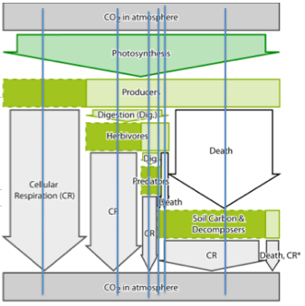

- Part III: Discuss the question as a class. Invite suggestions about why “matter cycles, but energy flows.”
- Part IV: Instruct students to write their explanations for what each group of arrows represent. Then, compare responses with groups. How did they interpret the arrows?

Activity 4: Pools & Fluxes Worksheet

Time: 30 minutes
Materials
- PoolsFluxes.doc

Rationale & Description:
This short reading and follow up questions are designed to help students think about how carbon movement in an ecosystem changes the sizes of the pools in various locations. They have seen this modeled in the Sunny Meadows investigation, as well as the Carbon Game. These questions are designed to help students apply what they saw modeled to questions about real ecosystems. Climate change, for example, is caused by the pool of carbon in the atmosphere growing too large. Understanding carbon pools and fluxes in an ecosystem is helpful for thinking about issues that involve large scale carbon cycling, like Climate Change.

Directions:
- Part I: Give each student a Pools & Fluxes Worksheet and give them a moment to read the story.
- Have students share their initial reactions from the reading. You might ask them “According to this, what is a pool? What is a flux? How do scientists measure these things?
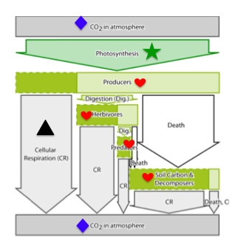
- Part II: When students are finished, their drawings may look something like this:

- Part III: After students have taken a few minutes to complete part III, take quick polls to see which boxes were checked and invite students to share their explanations.

Activity 5: Carbon Game II: Organic vs. Inorganic

Time: 30 minutes

Materials:
- GameWorksheet_OrganicInorganic.doc
- CarbonGame_OrganicInorganic.ppt
- Location Cards (6 total. Note: you may want to print more than one of each location cards for each round: Because there are only two pools in this game, the students will have trouble reading the cards if there is only one of each.)
  - Round 1 Organic.jpg
  - Round 1 Inorganic.jpg
  - Round 2 Organic.jpg
  - Round 2 Inorganic.jpg
  - Round 3 Organic.jpg
  - Round 3 Inorganic.jpg

Rationale & Description:
These additional carbon games build on the initial concepts introduced in the first Carbon Game, but focus just on two larger pools of carbon: organic & inorganic. Another way of thinking about these two pools are biotic & abiotic, or CO₂ & biomass. Questions that follow each round are designed to help students think about how photosynthesis and cellular respiration contribute to the moving of carbon atoms from the organic pool to the inorganic pool, and to help them think about the role of energy in ecosystems. Round 1 examines what happens to carbon atoms when there are even rates of cellular respiration and photosynthesis. Round 2 examines what happens to carbon atoms when rates of photosynthesis are lowered, and includes questions about energy. Round 3 examines what happens to the organic and inorganic pools of carbon when combustion enters the picture.

Directions:
- Print the location cards for each round.
- Place the location cards on opposite sides of the classroom.
- Open CarbonGame_OrganicInorganic.ppt and go through slides 1-5 to begin.
- Give each student a game worksheet.
- After round 1, pause and use slides 6-9.
- Play round 2.
- After round 2, pause and use slides 10-13.
- Play round 3.
- After round 3, use slides 14-16.

Activity 6: Carbon Game III - Farm Game

Time: 45 minutes

Materials:
- FarmGame.pptx
- ChartingOurPaths_Farm.xlsx
- Dice (1 for each student)
- FarmGameCard.doc (1 for each student)
- Round1Atmosphere.jpg
- Round1Corn.jpg
- Round1Human.jpg
- Round1Decomposers.jpg
- Round1Cow.jpg
- Round2Atmosphere.jpg
- Round2Corn.jpg
- Round2Human.jpg
- Round2Decomposers.jpg

Rationale & Description:
These additional carbon games build on the initial concepts introduced in the Meadow Ecosystem and Organic/Inorganic Pools, but examine the role of people in a food chain. Grass, rabbits, and fox are replaced with corn, cattle, and humans. In the meat-based food chain, corn is grown to feed cows, which are then eaten by humans. In the plant-based food chain, corn is grown to feed humans.

Directions:
- Give each student a FarmGameCard.com worksheet.
- Position the game cards in the classroom.
- Use slides 1-6 to introduce the game.
- Play Round 1.
- Use slides 7-12 to introduce round 2.
- Take down the round 1 location cards and put up round 2 location cards.
- Play round 2.
- Use slides 13-18 to conclude the game.
- Open ChartingOurPaths_Farm.xlsx.
- Input the data students collect and examine the charts for both rounds. How do the two compare?

Name: ____________________ Period: ____ Date: ________

Worksheet: Carbon Game Card (Meadow)

Directions: During the game, use the game card on the back of this page to record your data as you play the game. After you play the game, fill in the blanks below.

During The Carbon Game, I….

- …started in the ________________ pool.

- …ended in the ________________pool.

- …was in the AIR pool ________ times. To find the answer, count the number of colored squares in the arrows that point to the AIR pool, and the number of colored squares in the circle around the AIR pool. Then, count the number of colored squares in the circle around the air station. Add these two numbers together to get your answer.

- …was in the Producer pool ________ times. To find the answer, count the number of colored squares in the arrows that point to the PRODUCER pool.

- …was in the HERBIVORE station ________ times.

- …was in the CARNIVORE station ________ times.

- …was in the DECOMPOSER station ________ times.

- …was transformed by PHOTSYNTHESIS ________ times. To find the answer, count the number of colored squares in the arrow labeled photosynthesis.

- …was transformed by BIOSYNTHESIS ________ times. To find the answer, count the number of colored squares in all of the arrows labeled biosynthesis. These arrows are round; there are 4 of them.

- …was transformed by DIGESTION ________ times. Note: There are multiple arrows for digestion! Make sure to count them all.

- …was transformed by CELLULAR RESPIRATION ________ times. Note: There are multiple arrows for cellular respiration, too!

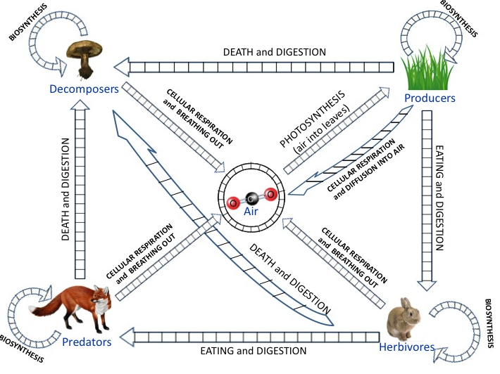

Name: ____________________ Period: ____ Date: ________

Worksheet: Tracing Our Paths

Part I
You just spent some time as a carbon atom moving around a simple ecosystem. You probably moved from the atmosphere pool to the producer pool. Some of you may have become part of an herbivore, carnivore, or decomposer. Each of you took unique paths through the ecosystem. What does that path look like in a real ecosystem?

- Draw some arrows that show how carbon can move from carbon dioxide in the atmosphere to organic matter in the ecosystem. Label these arrows with a #1.
- Draw some arrows that show how organic matter moves through the ecosystem. Label these arrows with a #2. Make sure your arrows include:
  - Plants
  - Rabbits
  - The fox
  - The soil
- Draw some arrows that show how carbon in organic matter can get back to carbon dioxide in the atmosphere. Label these arrows with a #3.
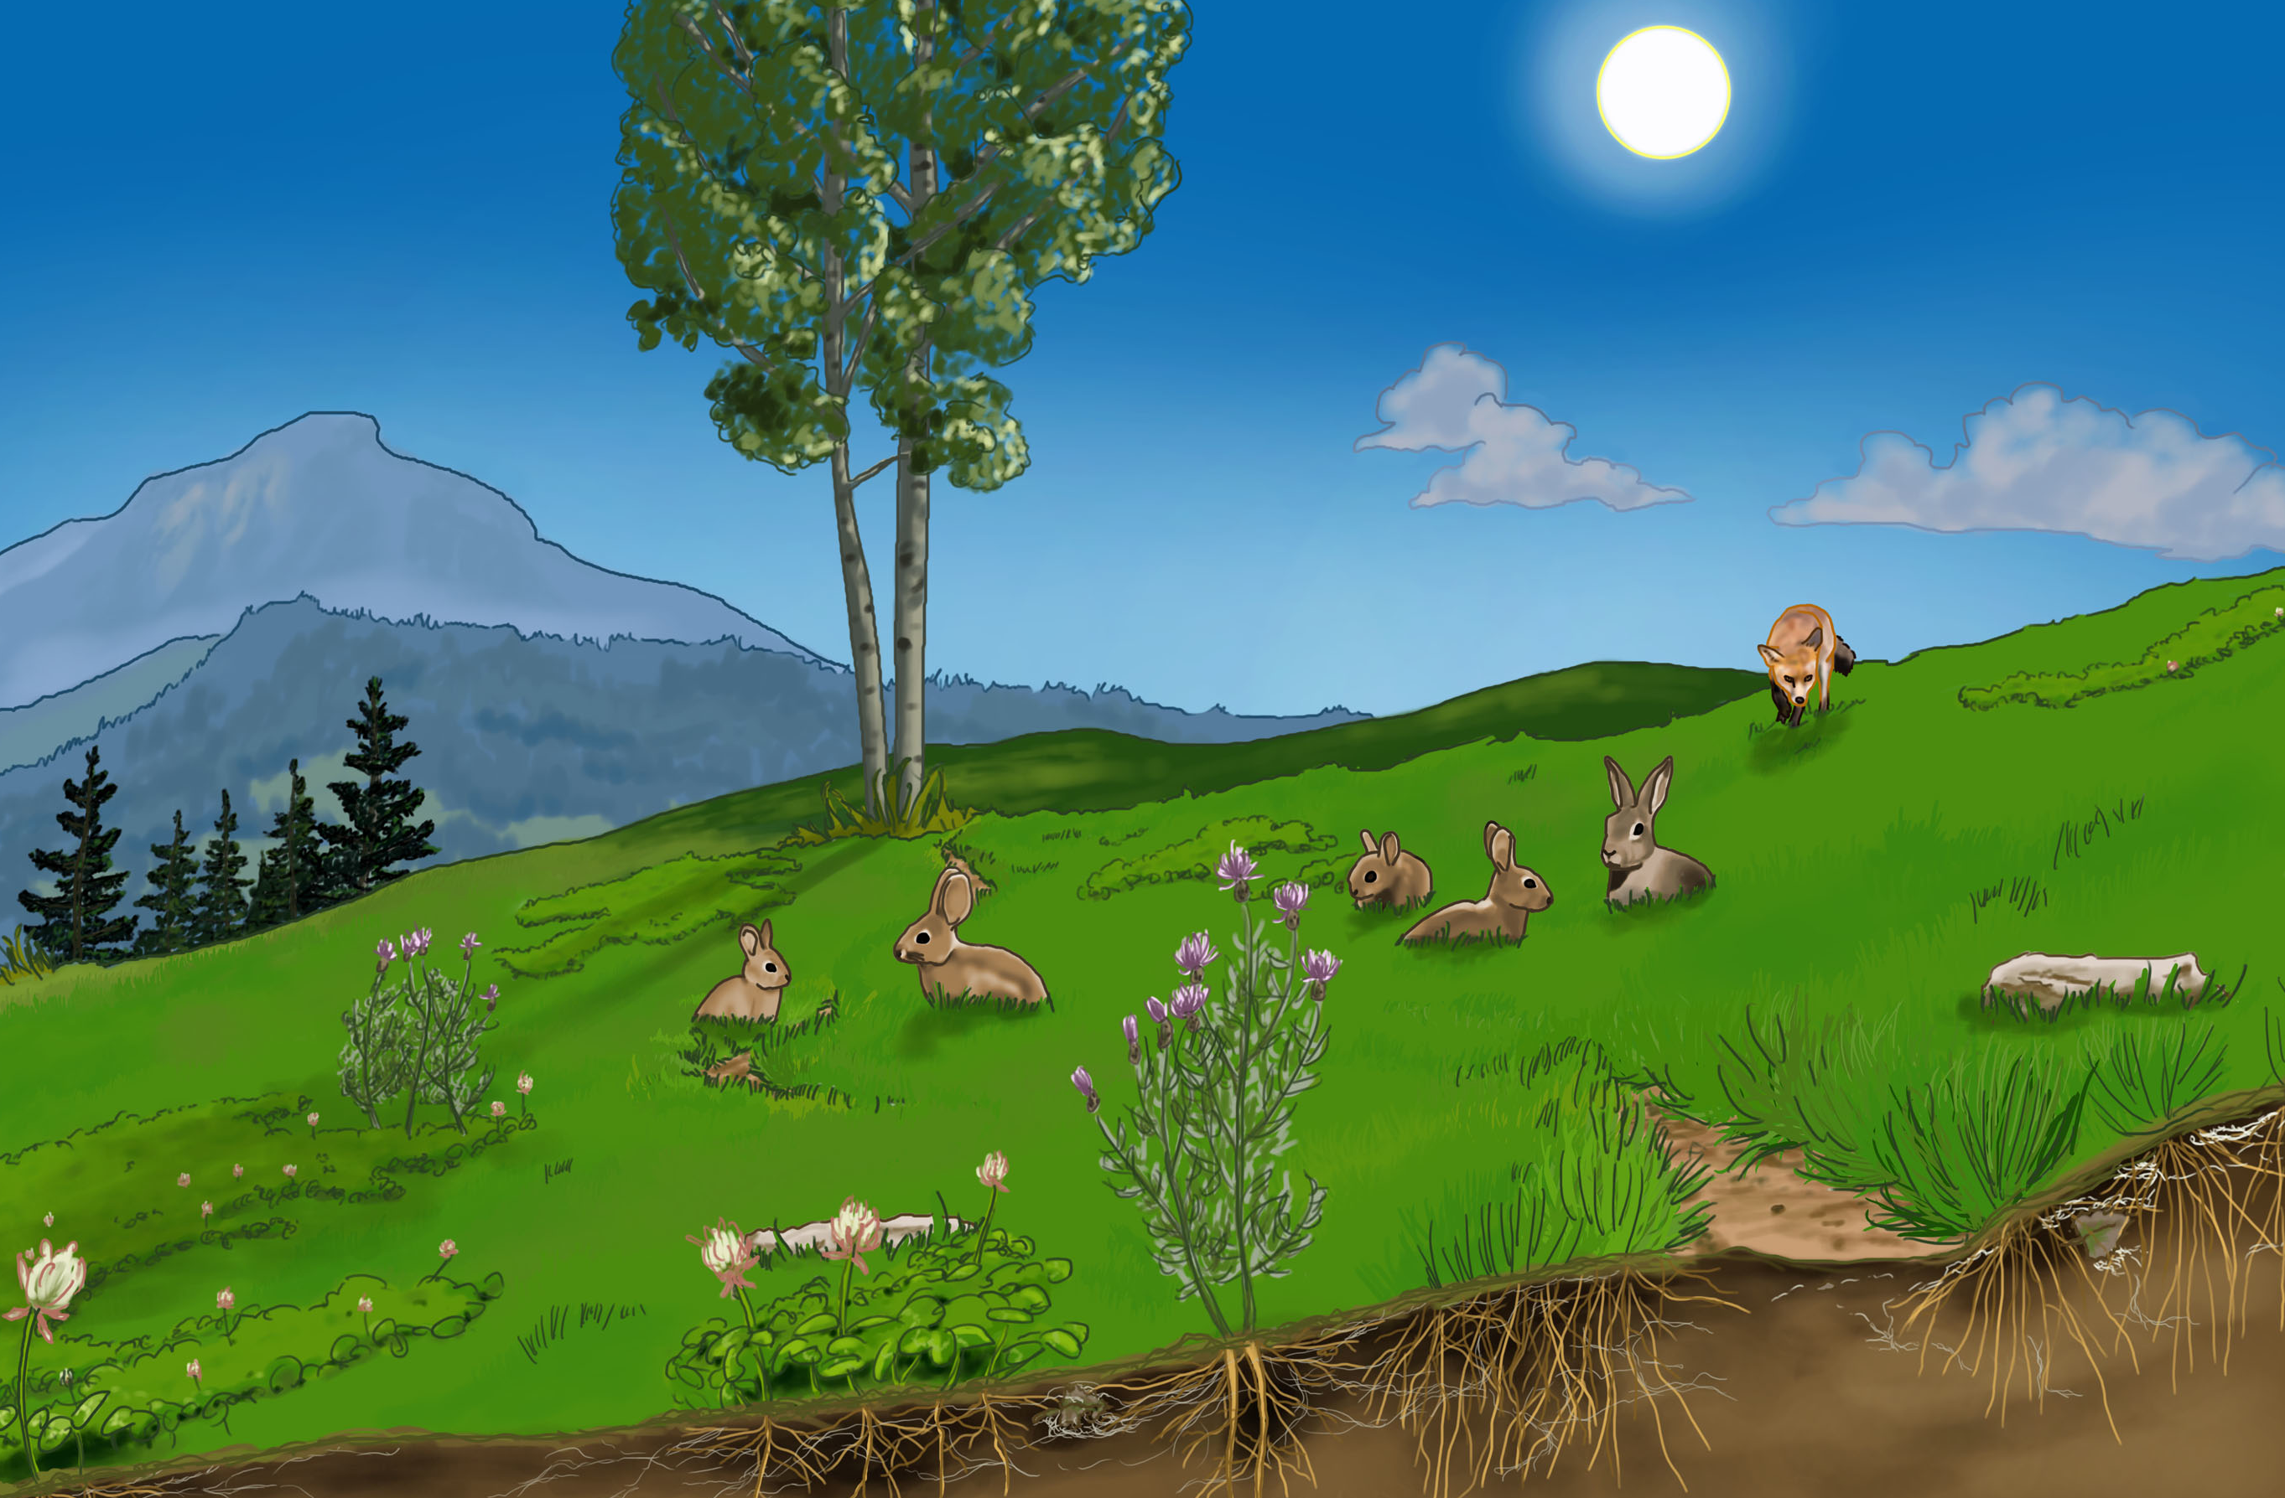
- How are the arrows labeled #1 (from the atmosphere to the ecosystem) and #3 (from the ecosystem to the atmosphere) different?

Part II
This diagram was designed to help you think about the carbon-transforming processes that the carbon atoms go through as they travel through an ecosystem. The arrows on the diagram represent carbon transforming processes or movements (also called “fluxes”), and the boxes represent locations in the ecosystem where carbon is located (also called “pools”).

- On the diagram below, draw 6 vertical lines. Each vertical line should begin in the atmosphere pool (the box on the very top) and end in atmosphere pool (the box labeled on the very bottom), passing through different arrows along the way.
- Draw a vertical line that matches each of the following paths:
  - Air➔Grass➔Air
  - Air➔Grass➔Soil➔Air
  - Air➔Grass➔Rabbit➔Fox➔Soil➔Air
  - Air➔Grass➔Rabbit➔Air
  - Air➔Grass➔Rabbit➔Soil➔Air
  - Air➔Grass➔Rabbit➔Fox➔Air
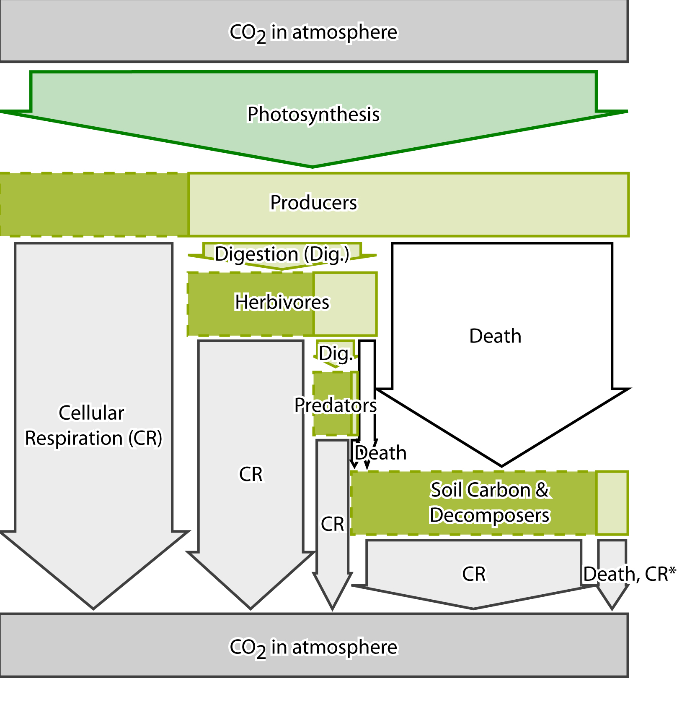

- Why do all of the lines above begin and end in the air?

- Which carbon-transforming process did you pass through every time? Why?

- Describe the carbon transforming processes that you would need to go through to follow this path: Air➔Grass➔Rabbit➔Fox➔Soil➔Air

- Describe the carbon transforming processes that you would need to go through to follow this path: Air➔Grass➔Soil➔Air

- Describe the carbon transforming process that you would need to go through to follow this path: Air➔Grass➔Air

- Which arrow in the arrow diagram above changes carbon from organic to inorganic?

- Which arrow in the arrow diagram above changes carbon from inorganic to organic?

Part III.
Some scientists say that “matter cycles, and energy flows.” When you were a carbon atom during the carbon game, you cycled through the ecosystem. You may have changed from organic to inorganic, or moved from one organism to another, but you never exited the ecosystem.

- Look at what happens to the energy in the diagram below. How is it different than matter? (Hint: the squiggley lines show things that are happening to energy).
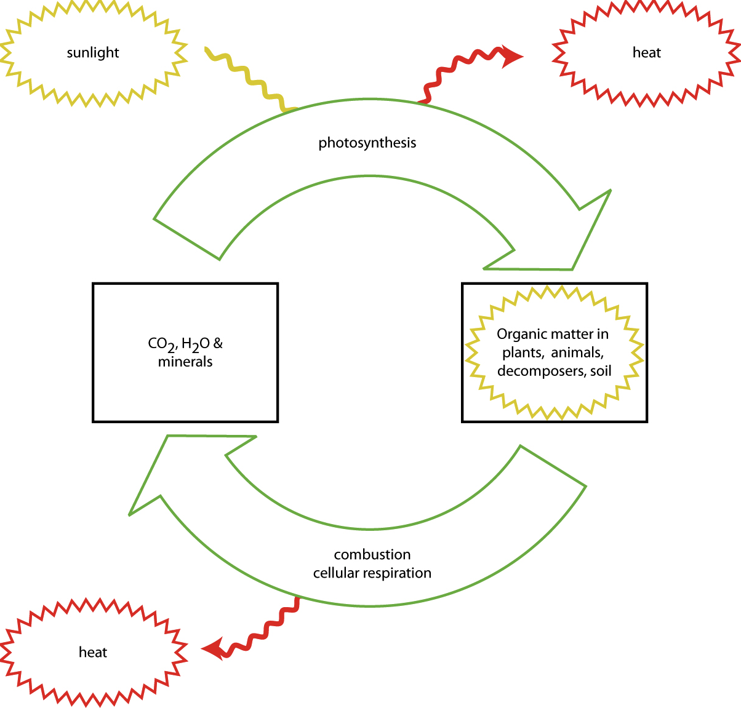
- What do you think happens to energy when things eat each other? Use the diagram below to help you construct an answer.
Part IV.
Have a look at this picture and the arrows in it. See if you can explain what the arrows mean.

Arrows 1 and 2: These arrows represent photosynthesis, or the removal of organic carbon from the atmosphere by the producers. The producers transform the inorganic CO₂ into organic biomass.

Arrows 3, 4, 5, 6, and 7: These arrows represent cellular respiration, or the movement of carbon from organic biomass into the atmosphere. During cellular respiration, carbon is transformed from organic molecules into water and CO2, and the CO2 is released into the atmosphere as a waste product of cellular respiration. You can also think of this as the transformation of organic carbon into inorganic carbon.

Arrow 8, 9, 10, 11, 12, and 13: This arrow represents the movement of carbon from the detritus (organic matter, once-living things, etc) in the soil through cellular respiration by the decomposers. CO₂ is released back into the air as a waste product of cellular respiration.

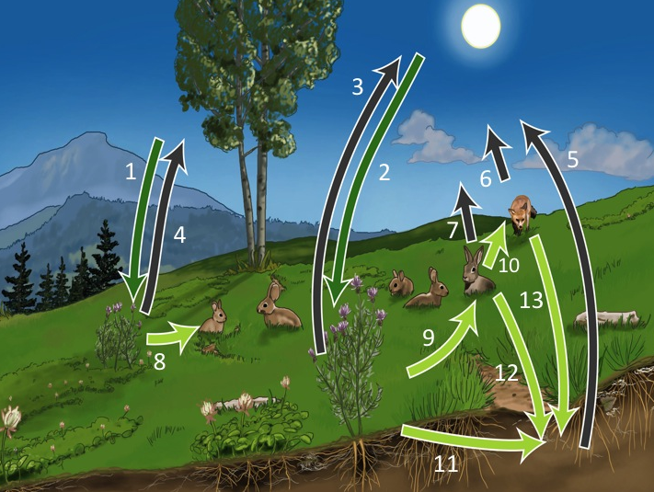
PART OPTIONAL
Draw a circle on this diagram that matches each of the following paths. Begin and end all of your circles in the box that says “CO₂, H₂O, and Minerals:.”
  - Air➔Grass➔Air
  - Air➔Grass➔Decomposers➔Air
  - Air➔Grass➔Rabbit➔Fox➔Decomposers➔Air
  - Air➔Grass➔Rabbit➔Air
  - Air➔Grass➔Rabbit➔Decomposers➔Air
  - Air➔Grass➔Rabbit➔Fox➔Air
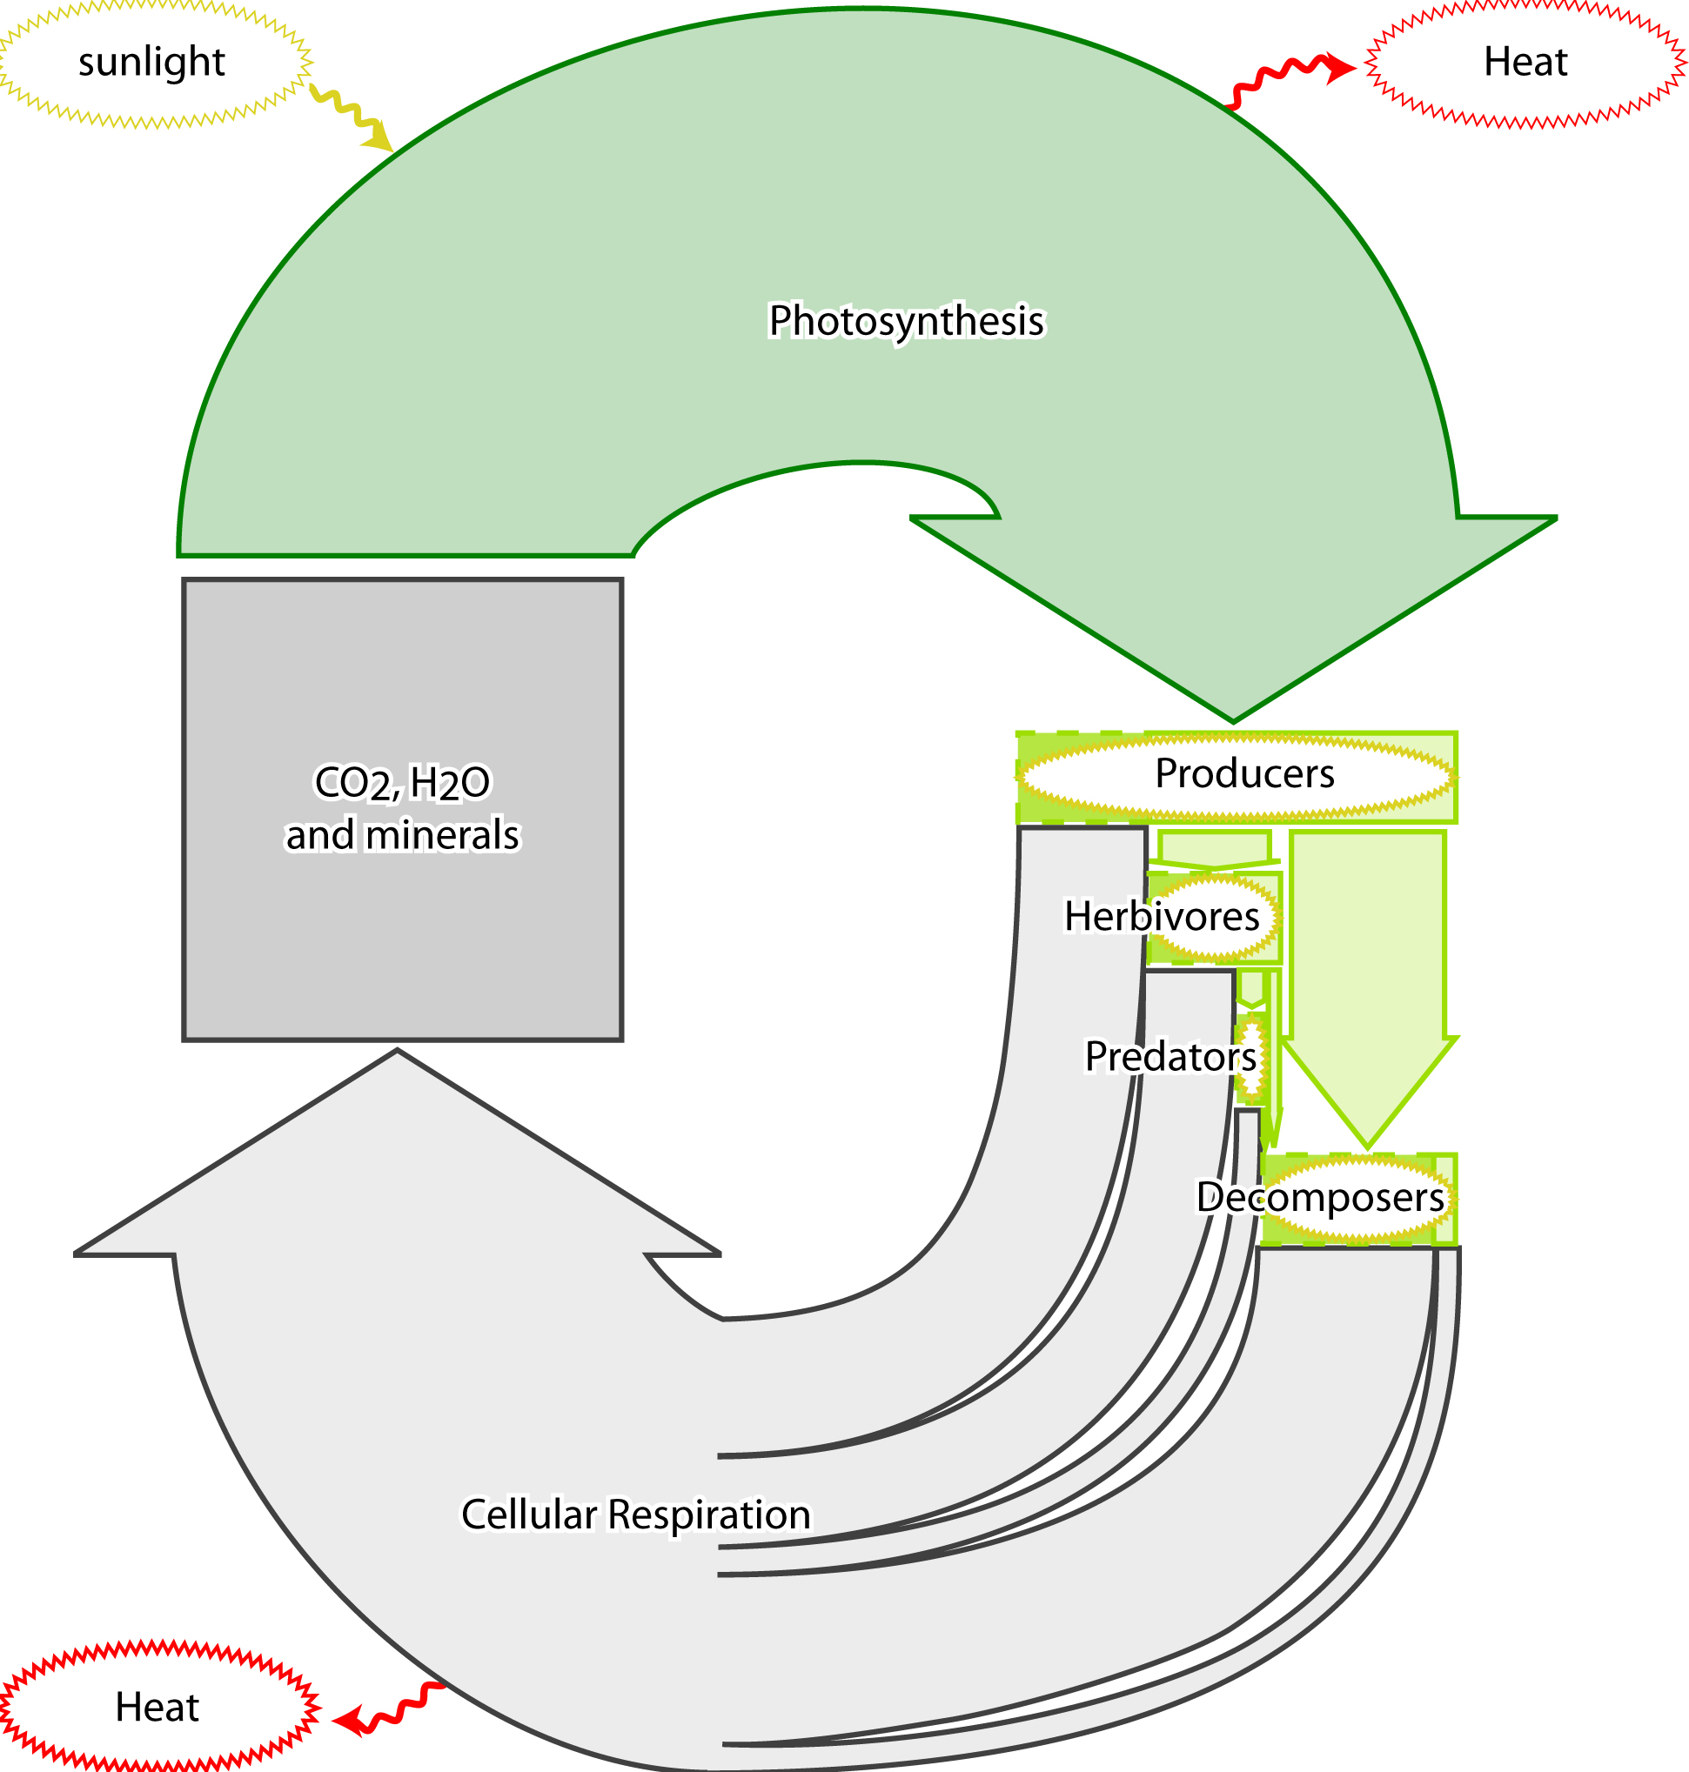

Name: ____________________ Period: ____ Date: ________

Worksheet: Pools and Fluxes

Part I.
Carbon is the most important element for living things. Every single living cell on Earth–plants, animals and humans—is made with carbon atoms. Humans are about 18 % carbon atoms by weight, and a human being who weighs 150 pounds contains about 7 hundred trillion carbon atoms (that’s 7 followed by 26 zeros!). That’s a lot of atoms. Carbon is such an important element that when scientists want to study large populations of living things (for example when they’re thinking about grasses in a meadow, or trees in a forest), scientists can study these living things just by counting carbon atoms. Looking at the world by counting carbon atoms allows scientists to think on a ecosystem-sized scale or even Earth-sized scale about where living things are located and how they change. Global climate change, for example, is causing lots of living things to change, and counting carbon on the landscape gives us important information about those changes.

In many ecosystems, one important place where lots of carbon atoms are located is in trees. Dr. Andres Schmidt at Oregon State University is an atom counter. He uses high-tech tools to measure carbon atoms, like 150 feet high towers that let him look out over the forest canopy. These towers count carbon atoms in the form of carbon dioxide (CO₂) molecules in the air, as well as keep track of meteorological conditions like moisture and temperature. There are more than fifty of these towers all across the United States in a network called AmeriFlux. These scientists want to know if forests can absorb extra carbon in the air due to fossil fuel combustion.

Scientists use special words, “pools” and “fluxes” when counting atoms. Carbon pools are reservoirs of carbon atoms in a particular part of the ecosystem, like plants, soils, animals or air. Pools are thought of as bigger than one individual animal or tree; for example, a pool could be all the grasses growing in a meadow ecosystem or all the rabbits living in a meadow ecosystem. In ecosystems we think of major pools of carbon as soil, plants, animals and air. Pools can be lots of different sizes, and scientists even talk about the “all the vegetation in the world” as one pool of carbon. Pools are usually measured by the mass of carbon in an area (for example, pounds of carbon per acre). Scientists like Dr. Schmidt also measure pools in lots of “low-tech” ways—they may actually walk through the forest measuring trees and fallen logs and collecting leaf litter! Since plants are about 50% carbon, the scientists like Dr. Schmidt are able to estimate how many carbon atoms are in a pool just by measuring trees and collecting leaves!

Fluxes are movements of carbon from one pool to another. Carbon moves through ecosystems by the carbon-transforming processes that we have studied: photosynthesis, respiration, biosynthesis, digestion (and combustion! We will talk about this soon). Fluxes are “rates” because they are measured as the amount of carbon that moves from one pool to another in a particular unit of time (for example, pound of carbon per acre per year). A flux is usually measured on a big scale, just like pools. For example, when the sun is shining on a forest, scientists like Dr. Schmidt can actually detect photosynthesis as a movement of carbon from the air pool to plant pools. When trees take in carbon during photosynthesis, the CO₂ in the air decreases above the forest. This movement of carbon from one pool to another is a flux!

Dr. Schmidt has a useful analogy for thinking about pools and fluxes. You can imagine a pool of carbon atoms like water in a swimming pool. Fluxes could include water that comes into the pool (like water from a hose), or water that leaves the pool (like a drain at the bottom). The water in the swimming pool might increase for two reasons: because water floods from the hose at a greater rate, or because the drain closes to a drip. In forests, water coming from the hose is like carbon entering the forest pool during flux from photosynthesis, and water leaving through the drain is like carbon leaving the forest pool during flux from respiration. Forest pools increase or decrease depending on photosynthesis and respiration rates. Forests may absorb 2000 pounds of carbon per acre (in a certain amount of time) in photosynthesis, but then respire 1,500 pounds of carbon per acre (in the same amount of time). That would leave 500 pounds of C in the forest pool. An “increase in the carbon pool” of a forest simply means that the trees are growing!

Part II
In the carbon game, where were all the pools of carbon? In the picture below, the pools are represented by boxes.
  - Draw a heart on the boxes that represent organic pools of carbon.
  - Draw a diamond on the boxes that represent inorganic pools of carbon.
In the carbon game, what were all the fluxes? In the picture below, find the arrows that represent fluxes.
  - Draw a triangle on a flux arrow that increases levels of CO₂ in the air.
  - Draw a star on a flux arrow that decreases levels of CO₂ in the air.

Part III
Read each scenario. Put a check next to the best choice. Explain your choice underneath each example.

In South America 2 million acres of cattle farm is planted with trees and turned into a forest.
☐ Increase carbon in the atmosphere.
☐ Decrease carbon in the atmosphere.
Explain:

The prairie surrounding the Gobi Desert disappears due to over-grazing by cattle. The desert spreads into the area where prairie used to be, covering the area with sand.
☐ Increase carbon in the atmosphere.
☐ Decrease carbon in the atmosphere.
Explain:

A prairie is plowed to make a cornfield. The plowing of the field breaks up plant roots and stems, so that they are digested more rapidly by decomposers.
☐ Increase carbon in the atmosphere.
☐ Decrease carbon in the atmosphere.
Explain:

Wind turbines are used to generate electricity at a power plant instead of burning coal.
☐ Increase carbon in the atmosphere.
☐ Decrease carbon in the atmosphere.
Explain:

In the Amazon Rain Forest, 2 million acres of trees are harvested to make room for a cattle farm.
☐ Increase carbon in producers.
☐ Decrease carbon in producers.
Explain:

Cattle are removed from the prairie surrounding the Gobi Desert. The prairie regrows and stops the spreading of the Gobi desert.
☐ Increase carbon in producers.
☐ Decrease carbon in producers.
Explain:

In Yellowstone National Park, wolf populations are increasing and they are eating more elk calves.
☐ Increase carbon in consumers.
☐ Decrease carbon in consumers.
Explain:

Name: ___________________ Period: ____ Date: ________

Game Card (Organic Inorganic)
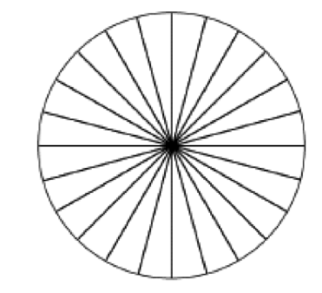
Round 1
Organic Pool
Inorganic Pool
Round 2
Organic Pool
Inorganic Pool
Round 3
Organic Pool
Inorganic Pool

Name: ___________________ Period: ____ Date: ________

Farm Game Card Round 1

During The Meat-Based Farm Game, I….

- …started in the ________________ pool.

- …ended in the ________________pool.

- …was in the AIR pool ________ times. To find the answer, count the number of colored squares in the arrows that point to the AIR pool, and the number of colored squares in the circle around the AIR pool. Then, count the number of colored squares in the circle around the air station. Add these two numbers together to get your answer.

- …was in the CORN pool ________ times. To find the answer, count the number of colored squares in the arrows that point to the PRODUCER pool.

- …was in the COW station ________ times.

- …was in the HUMAN station ________ times.

- …was in the DECOMPOSER station ________ times.

- …was transformed by PHOTSYNTHESIS ________ times. To find the answer, count the number of colored squares in the arrow labeled photosynthesis.

- …was transformed by BIOSYNTHESIS ________ times. To find the answer, count the number of colored squares in all of the arrows labeled biosynthesis. These arrows are round; there are 4 of them.

- …was transformed by DIGESTION ________ times. Note: There are multiple arrows for digestion! Make sure to count them all.

- …was transformed by CELLULAR RESPIRATION ________ times. Note: There are multiple arrows for cellular respiration, too!

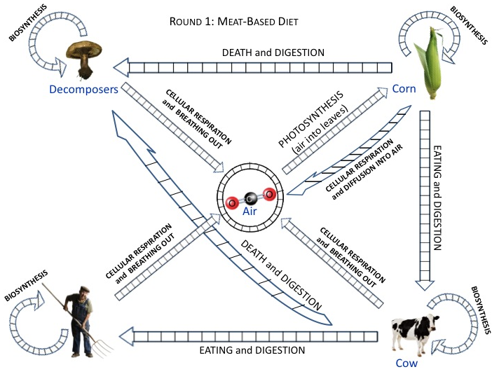

Farm Game Card Round 2

During The Plant-Based Farm Game, I….

- …started in the ________________ pool.

- …ended in the ________________pool.

- …was in the AIR pool ________ times. To find the answer, count the number of colored squares in the arrows that point to the AIR pool, and the number of colored squares in the circle around the AIR pool. Then, count the number of colored squares in the circle around the air station. Add these two numbers together to get your answer.

- …was in the CORN pool ________ times. To find the answer, count the number of colored squares in the arrows that point to the PRODUCER pool.

- …was in the HUMAN station ________ times.

- …was in the DECOMPOSER station ________ times.

- …was transformed by PHOTSYNTHESIS ________ times. To find the answer, count the number of colored squares in the arrow labeled photosynthesis.

- …was transformed by BIOSYNTHESIS ________ times. To find the answer, count the number of colored squares in all of the arrows labeled biosynthesis. These arrows are round; there are 4 of them.

- …was transformed by DIGESTION ________ times. Note: There are multiple arrows for digestion! Make sure to count them all.

- …was transformed by CELLULAR RESPIRATION ________ times. Note: There are multiple arrows for cellular respiration, too!

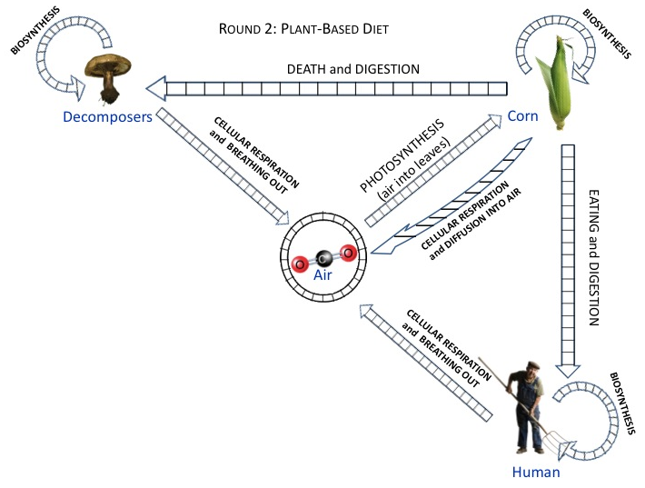

Core Lesson 4: Ecosystems in our Schoolyard

Time/Duration: 135 minutes
Activity 1: Draw Your Own Ecosystem ~15 minutes
Activity 2: Satellite Images of our Community
Activity 3: Where do People Stand in the Food Chain?
Activity 4: How does Carbon Cycle through our Schoolyard?
Activity 5: How do Forest Fires Change an Ecosystem?

Guiding Question:

Model Response:
Alex | Blake | Carmen

Learning Objectives:

Objectives for students at Level 2 | Objectives for students at Level 3
To be determined | To be determined

Rationale & Background:

Lesson Description:

Lesson Materials:

Activity 1: Your Own Ecosystem

Time: 15 minutes
Materials:
- Draw Your Own Ecosystem.doc

Activity 2: Satellite Images of our Community:

Time: two 30 minute periods

Rationale & Description:
This activity is designed to give students a chance to apply their knowledge of carbon cycling in ecosystems to their current surroundings by comparing a satellite image of their community with stock images of various ecosystems provided. Students examine provided satellite images of various ecosystems (meadow, forest, farm, urban square, suburban cul-de-sac, park, etc). In pairs or groups, students retrieve a satellite image of their community or school. Then they use this image to compare their community’s images to the images they examined together with consideration of which ecosystems store carbon differently and how carbon and energy cycle through the various spaces. Some questions that could be addressed include:
- What decisions have been made that have changed the amount of carbon that various spaces can hold?
- How does carbon cycle through images in the various pictures?
- How did the image of their neighborhood come to look the way it does?
- What decisions could be made to change our schoolyard?
- How would that change the way carbon is cycled in these spaces?

Directions:

Activity 3: How do Our food choices Change the carbon cycle?

Time:

Rationale & Description: This activity would focus on human’s roles in the ecosystem and how choices about food affect the carbon cycle. Students each bring in one item of food from home (half are assigned a vegetarian item and half are assigned an item with a meat product) and examine the ingredients (for a whole food like an apple, there is only one ingredient. For a processed food like a granola bar or a can of chef Boyardee ravioli, there will be more than one ingredient). Students trace the path of carbon from the atmosphere to their food product, to the person who will eat it. Possible questions that could be used in this activity include:
- Through how many steps in the food chain does it take to get to them?
- Where do photosynthesis, digestion, biosynthesis, and respiration play a role?
- Can we trace the path of carbon through our food web process tool?
- Of all food items brought into class, through which item was the least amount of carbon returned to the atmosphere through respiration on its path through the food chain? (a whole food or veggie item most likely)
- Of all food items, which required the cycling of the most amount of carbon (a meat item most likely).
- How do our food choices affect the amount of carbon that is put into the atmosphere?
Alternatively, we could have students record their eating habits for an entire week and compare in similar ways – for both of these we would need some way to quantify or estimate qualitatively how much carbon (originally photosynthesized by the producers) is released back into the atmosphere in the process of the creation of the food item in question.

Activity 4: Schoolyard Plots: How does Carbon cycle through our schoolyard?

Time:

Rationale & Description: Students select 1m x 1m plots in their schoolyard (lawn, garden, forest, any place with vegetation, etc). They trace the path of carbon in their particular plot and make comparisons to the carbon cycle in their plot to the carbon cycle in the plots of other students. Possible questions to accompany this activity:
- Which plot do you think contains the most/least carbon? (i.e., a plot with sand vs. a plot with grass)
- How could these plots be changed to contain more/less carbon?
- How long do these plots keep their carbon? (ie., a plot with a tree vs. a plot with only grass)
- How does the carbon path through this plot look on the food web process tool?

Activity 5: How do forest fires change an ecosystem?

Time:

Rationale & Description: Students read an article about management of forest fires. They consider how carbon cycles through a forest that burns regularly and how carbon cycles through a forest in which fire is suppressed. Possible questions to accompany this activity:
- How does burning regularly create a balance of carbon cycling over time? (regular burning maintains the ecosystem and there fore maintains a balanced carbon cycle over time)
- How does the suppression of burning create an imbalance (fires with lots of fuel that burn too hot render ecosystem unable to support much life and therefore create an imbalance in the carbon cycle)
- How does carbon cycle through a forest that burns regularly? (which are sustainable over time)
- How does carbon cycle through a forest in which fires are suppressed? (which burn too hot and damage the ecosystem)

Name: ____________________ Period: ____ Date: ________

Worksheet: Draw Your Own Ecosystem

Directions: in the box below, draw an ecosystem you are most familiar with. In the drawing, include
- A producer, an herbivore, a carnivore, and a decomposer.
- Arrows that show photosynthesis, digestion, biosynthesis, and cellular respiration, and
- Arrows that show where energy comes into and leaves the ecosystem.

